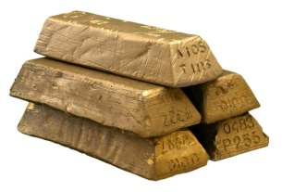
West African Empires

Introduction: As African civilizations developed, great trading states arose in West Africa. Traveling across the desert and over the wide Indian Ocean, merchants from these states helped make their people rich and powerful. Trade not only resulted in a transfer of ivory, gold, and other valuable merchandise, but also in a transfer of cultures, religion, languages, and new ideas.

Task: Use the “West African Empires” research list on the ABC-CLIO Ancient History database to learn about Ghana, Mali, and Songhai.

Part A: Fill in the table below with facts gathered from the articles, visuals, etc.

 | GHANA | MALI | SONGHAI
Time Period

Life in the Empire (Gov’t, Economy, Religion, etc.)

Fall/Decline of the Empire

Part B: Briefly summarize the life of each individual below and explain his significance to the trading empires of West Africa.
Individual | Brief Biography & Significance
Sundiata

Individual | Brief Biography & Significance
Mansa Musa

Ibn Batutta

Sunni Ali

Part C: Fill in the Venn Diagram below to compare and contrast the three African kingdoms you researched in Part A & B.

Ghana Mali

Songhai

