The Five Pillars of Islam
The Five Pillars of Islam represent the duties of a Muslim. Like the Ten Commandments, they provide a spiritual foundation and function. These duties will be explained in detail in the following pages.
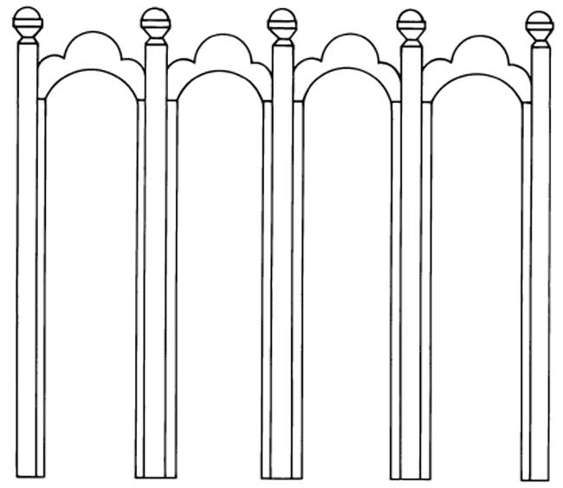
Shahada | Salat | Zakzt | Sawm | Hajj
Declaration of faith in Allah | Prayer towards Mecca five times daily | Almsgiving or welfare contribution | Fasting during Ramadan | Pilgrimage to Mecca
The First Pillar: Shahada
The first Pillar of Islam is called shahada. It is a brief prayer proclaiming the oneness of God and faith in Islam. Children memorize the shahada, an action which introduces them into the Islamic community. The shahada simply states:
"There is no God but God,
and Muhammad is the messenger of God."
Here is the shahada written in Arabic. (Like Hebrew, Arabic is written from right to left.)
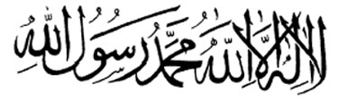
Arabic was Muhammad's native tongue, the language in which he claimed to have received the Koran. Many devout Muslims from outside Arabic-speaking countries will learn the language in order to read the Koran in its original form. In fact, some Muslims consider any translation of the scripture totally unacceptable. Here is a map of Arabic-speaking countries.
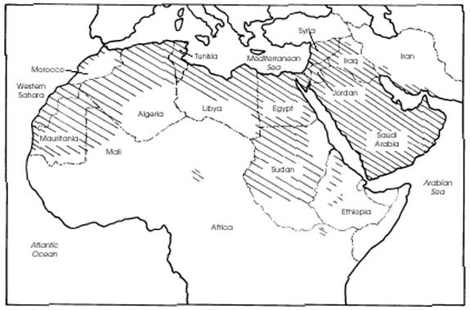
The Second Pillar: Salat
The second pillar is called salat. It requires Muslims to pray five times a day toward Mecca. They must pray at sunset, in the evening, at dawn, at noon, and in the afternoon. In Muslim countries, the call to prayer is announced from a minaret atop a mosque. A mosque is where Muslims gather to pray, although it is acceptable to pray alone. In many Islamic countries, women pray at home. If they pray with the men, they do so from behind them or in a separate group. The leader of a mosque is called an imam, which means "one who walks before." The imam leads the prayer and gives sermons. However, unlike a priest or rabbi, the imam does not hold special authority. Instead, he is chosen by virtue of his dedication and sincerity. (As you will see, the title of imam holds a very different meaning for the Shiah sect of Muslims.)
Each prayer involves different bowing positions, or rakahs. In the morning prayer, for example, after laying out his prayer mat, the devotee raises his hands, touches his earlobes, and proclaims, "Allahu akbar!" meaning "God is great!" Next, he rests his hands at his waist and recites the first verse of the Koran. The prayer continues when the worshipper bows, prostrates himself, and sits back, each time declaring faith in Muhammad and Allah. If the person is in a mosque, he will turn to either side and wish another person peace and blessings.
The Bowing Positions of Salat
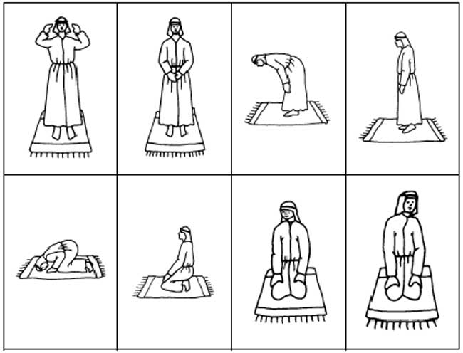
The Third Pillar: Zakat
Almsgiving, or zakat, is the third basic requirement. Muslims are expected to give to the poor and sick. Although the zakat is not regulated by the government, sincere Muslims regard it as an important religious duty. In fact, the Koran addresses almsgiving as an essential quality of an honest Muslim, a gateway into heaven.
The Fourth Pillar: Sawm
Sawm is perhaps the most demanding of the Five Pillars. It requires that Muslims fast during the month of Ramadan. Ramadan is the ninth month of the Islamic calendar. During this period, food and drink are not allowed between dawn and sunset. After sunset, only light snacks are allowed.
The fast represents a special time of purification and religious devotion. Stronger ties are made with family and community. Alcohol and tobacco are prohibited the entire month. Both the elderly and children are exempt from the fast.
The Festival of Eid-AI-Fitr
When the month of Ramadan ends, the festival Eid-al-fitr is celebrated. The rejoicing begins on the first day of the tenth month of the Islamic calendar. Although the month of Ramadan is spent fasting, families begin preparing for the celebration far in advance, sending cards to relatives and preparing gifts.
When the day finally arrives, Muslims attend special morning prayers in the local courtyard or park. In western countries, the faithful usually take the day off from work or school. In Muslim countries, Eid-al-fitr is considered a three-day national holiday! Throughout the celebration, presents are shared and families gather to rejoice. It is also a time to share food and money with those less fortunate.
The Fifth Pillar: Hajj
Exhort all men to make the pilgrimage. They will come to you on foot and on the backs of swift camels from every distant quarter . . .
Then let the pilgrims spruce themselves, make their vows, and circle the Ancient House. Such is Allah's commandment.
�(Koran, Surah 22, The Pilgrimage)
Hajj is the pilgrimage to Mecca which every Muslim is expected to make at least once. A pilgrimage is a journey to a sacred place or shrine. Unlike the other four Pillars, the Hajj can be skipped if it involves great hardships.
Over two million Muslims journey to Mecca each year, and each worshipper must follow certain guidelines. First, the men are expected to shave their heads and wear a piece of white garment around the waist and over the shoulder. Women wear the clothing of their native countries, though they must keep their heads covered at all times.
First, the pilgrims walk counter-clockwise seven times around the Ka'bah, either kissing or touching the stone. Next, they run seven times between the hills of As-Safa and Al-Marwah. This action is symbolic of Hagar's search for water and the miracle of the well, Zamzam.
After spending the night at the village of Mina, pilgrims take the next step, the wakuf, together. They meet at the plain of Arafat, about six miles from Mecca. From noon to sunset, they pray quietly. Next, they climb a small mountain called the Mount of Mercy, and they ask God's forgiveness for their sins. They spend the night at Muzdalifah.
Afterwards, they return to the village of Mina where the ritual of "stoning the devil" takes place. Followers gather pebbles which they throw at three pillars. This is symbolic of Abraham throwing stones at the Devil who had disturbed his prayers. On the tenth day, animal sacrifices�sheep or goat� are carried out. Finally, the pilgrimage again goes seven times around the Ka'bah.
Muslims conduct a four-day celebration upon returning home from Mecca. The Eid al-Adha, or Festival of Sacrifice, marks the end of the pilgrimage and acknowledges the great accomplishment. Now the male pilgrim has the right to call himself a hajji while the woman is called a hajjah.
The Rout of the Hajj
