SUMMER ASSIGNMENT DUE FRIDAY 8/4!!!
SUMMER ASSIGNMENT PART 1: Crash Course Ep 7, & 9
For these questions you will watch episodes 7, & 9 of Crash Course World History on Youtube Answer the following questions in concise bullet points(IN YOUR OWN WORDS, NOT DIRECT QUOTES FROM VIDEOS OR COPIED FROM OTHER STUDENTS) ANY EVIDENCE OF PLAGARISM OR COPYING WILL RESULT IN AN IMMEDIATE ZERO . A link to these videos can also be found at this website:
WEBSITE: PFANNENSTIELHISTORY.WEEBLY.COM
CONTACT: ANDREW.PFANNENSTIEL@TUSD1.ORG
:2,000 Years of Chinese History! Episode #7
1) Why is China considered the first modern state?

2)History in China was divided into ______________________________________
3)How do dynasties end in Chinese history?

5)Define the Mandate of Heaven

6)What is the purpose of the Mandate of Heaven?

7) How did the Han Dynasty use the Mandate of Heaven to justify their rise to power?

8)Describe who Confucius was

9)Describe at least 3 beliefs/teachings of Confucius

10) What is filial piety?

11)How does the Mandate of Heaven help explain how dynasties end/collapse?
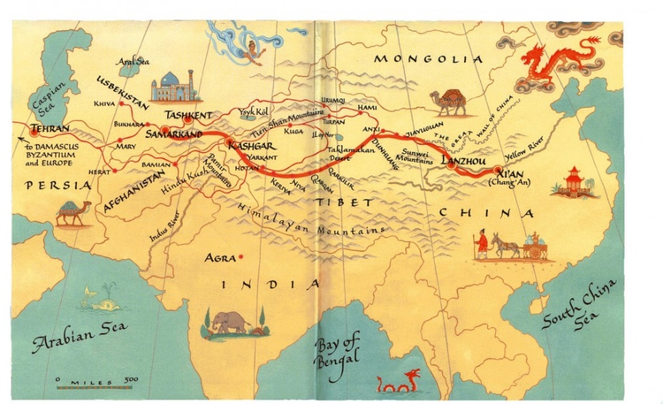
The Silk Road and Ancient Trade Episode #9:

1)Define the term Silk Road

2)What areas did the two routes of the Silk Roads connect?

3)Besides land routes, what other routes were there?

4)What should we think of the Silk Road as instead of an actual road?

5)Why is silk such a sought after and desirable item?

6)What other goods, beside Silk, were traded as part of the Silk Road?

7) Why did nomads make such good traders?

8)Why did trading cities develop and grow on the Silk Road?

9)How did the merchant class get political power?

10)How did silk production/trade impact people’s lives even though most people couldn’t afford it?

11)What was, arguably, the most important thing traded along the Silk Roads?

12)What is the third way that the Silk Road changed lives?

SUMMER ASSIGNMENT PART 2 VOCAB
These terms can be looked up online, but be sure to write definitions in your own words. Do not just copy definitions from the internet, quizlet, ect
Resources to use can be found on the WEBSITE: PFANNENSTIELHISTORY.WEEBLY.COM
TERM | DEFINITION | EXAMPLE  (Religion, civilization, group, ect this term is related to/from)
Feudalism | The political, social & economic system. It is a loosely organized system of government in which local lords governed their own lands but owed military service and other support to a greater lord. | Japan during the Heian Period with peasants, samurai, and daimyo
Belief Systems
City-States
Civil Service Exam
Commerce
Craft-Specialization
Demographic
Empire

TERM | DEFINITION | EXAMPLE  (Religion, civilization, group, ect this term is related to/from)
Gender Roles
Ideology

Labor System

Mandate of Heaven

Missionaries

Nomadic Empire

Pandemic/Epidemic

Social Class

Trade network

SUMMER ASSINGMENT PART 3: 6 THEMES OF WORLD HISTORY
Directions: Using the reading provided summarize the most important information and characteristics that fit into each of the 6 Themes of World History below. You can summarize each theme in bullet point information. You will also be identifying 3 examples of each of the themes of world history. These examples can come from the reading provided, the modern world, or from your knowledge of history.
THEME | SUMMARY OF THEME  (Look for key ideas, characteristics, topics, ect that fit into this theme) | IDENTIFY AT LEAST 3 SPECIFIC EXAMPLES
HUMANS AND THE ENVIRONMENT (ENV)
CULTURAL DEVELOPMENTS AND INTERACTIONS (CDI)
GOVERNANCE (GOV)

THEME | SUMMARY OF THEME  (Look for key ideas, characteristics, topics, ect that fit into this theme) | IDENTIFY AT LEAST 3 SPECIFIC EXAMPLES
ECONOMIC SYSTEMS (ECN)

SOCIAL INTERACTIONS AND ORGANIZATION (SIO
TECHNOLOGY AND INNOVATION (TEC)

6 THEMES OF WORLD HISTORY
The themes serve as the connective tissue of the course and enable students to create meaningful connections across units. They are often broader ideas that become threads that run throughout the course. Revisiting them and applying them in a variety of contexts helps students to develop deeper conceptual understanding. Below are the themes of the course and a brief description of each.
Theme 1 | HUMANS AND THE ENVIRONMENT (ENV)  The interaction between humans and the environment is a fundamental theme for world history. The environment shaped human societies, but increasingly human societies also affected the environment. For example how humans have altered their environment to grow crops, mine natural resources, build cites, ect. Environmental factors such as rainfall patterns, climate, and available plant life/crops, and animal life have a significant impact on the development of civilizations throughout history. The access to natural resources that can be used as fuel resources, building materials, create tradable items, ect is another significant characteristic of this theme. The outbreak and spread of diseases and how they impact the lives, governments, and economies of those affected is another major aspect of the theme of Humans and the Environment. The migration of humans is the final significant aspect of this theme. For example why groups chose to move or are forced to be moved from a region, where do they move, and what impact does this have; both on the regions being left and the regions being moved to.  During prehistory, humans interacted with the environment as hunters, fishers and foragers, and human migrations led to the peopling of the earth. As the Neolithic revolution began, humans exploited their environments more intensively, either as farmers or pastoralists(nomadic people raising livestock). As people flocked into cities or established trade networks, new diseases emerged and spread, sometimes devastating an entire region. During the Industrial Revolution, environmental exploitation increased exponentially. By the 20th century, large numbers of humans had begun to recognize their effect on the environment and took steps toward a “green” movement to protect and work with the natural world instead of exploiting it.
Theme 2 | CULTURAL DEVELOPMENTS AND INTERACTIONS (CDI)  There are many things that fall under the umbrella of the term culture. Culture can mean religion, languages spoken/written, the types of food eaten and other dietary habits, clothing styles, and fashion trends, as well as art and architecture. This theme also deals with how all these different aspects of culture influence and interact with one another. For example how does the religion of a region influence the type of food eaten, the clothing style, the focus of the art/literature created, and the architecture that is built.  Studying the dominant cultural characteristics of a region can reveal how major groups in society view themselves and others, and how they respond to multiple challenges. When people of different societies interact, they often share components of their cultures, deliberately or not. The processes of adopting or adapting new belief and knowledge systems are complex and often lead to historically novel cultural blends. This process is called Cultural Diffusion. A region’s culture may be investigated and compared with other societies’ cultures as a way to reveal both what is unique to a culture and what it shares with other cultures. It is also possible to analyze and trace particular cultural trends or ideas across human societies.
Theme 3 | GOVERNANCE (GOV)  This is all about government and power. One of the most important aspects of this theme is the type of government specific civilizations adopt. When exploring this them you can ask questions such as:  Who has the power and what do they do with this power? Does a government’s power come from the people or is there a dictator or powerful military group in control of an area? Does the civilization specifically state what kind of government or political philosophy they rely on? For example, is there a monarchy, is the government led by elected officials, communism, fascism, ect. What role does religion play in the government of each civilization?  This theme also has to do with what kind of laws civilizations have and how those laws are created. As well as how they are enforcement. who does the enforcing, and the kinds of punishments that used when these laws are broken.  This theme deals with things like warfare and conflict between and within in civilizations as well as the causes of these conflicts. Military and warfare are significant aspects of this theme as well. For example, what does the military in an area look like, how big is the military and how important is the military in that area, and who is and who is not involved in the military.  This theme also involves the creation of borders, the enforcement and maintenance of those borders as well as how these borders have changed overtime or are disputed.  Finally, this theme encourages students to explore how civilization interact with each other in many different ways. This can include the warfare, diplomacy, commercial and cultural exchange, and the formation of international organizations.
Theme 4 | ECONOMIC SYSTEMS (ECN)  This theme surveys the diverse patterns and systems that human societies have developed as they exploit their environments to produce, distribute and consume desired goods and services across time and space. Simply put this theme is focused on how a civilization or region makes its money, who does the work(labor), and the kind of trade that the civilization or region participates in. Is the civilization or region primarily focused on agriculture, mining natural resources such as coal, gold, ect, the production and sale of craft items such as textiles or pottery, or long-distance trade.  If a civilization or region is focused mostly on agriculture, what kind of crops are grown, who is responsible for working in the fields, and what is done with the crops once they are harvested.  As time progresses, most civilizations or regional economies become more diverse and are combination of agriculture, production of craft items, and trade.  Another major aspect of this theme related to who is doing the work in the economy. Who does the work in a particular civilization is called labor systems. For example, most areas rely on some form of coerced(forced) labor, such as some form of slavery, while other use some sort of paid labor or rely on people working on agricultural land they own and live on.  This theme also calls attention to patterns of trade and commerce between various societies, with particular attention to the relationship between regional and global networks of communication and exchange, and their effects on economic growth and decline. These webs of interaction strongly influence cultural and technological diffusion, migration, state formation, social classes and human interaction with the environment.
Theme 5 | SOCIAL INTERACTIONS AND ORGANIZATION (SIO)  This theme is about relations among human beings and how people are organized or grouped in a civilization. All human societies/civilizations develop ways of grouping their members based on a combination of different categories. This is called Social hierarchy. Which can be defined as a society’s categorization of its people into rankings of based on factors like wealth, income, race, education, perceived gender, and power. Another significant part of social stratification are the norms that govern interactions between individuals and social groups based on where they fall in the hierarchy. Throughout most of history and in most civilizations this social hierarchy looks like a pyramid, with the largest numbers of people group in the bottom of the pyramid. When examining a civilization ask yourself, what does this social pyramid look like? Who is grouped where? What impact does this social pyramid have on the people involved and the society as a whole?  Important ideas to keep in mind with this theme are what kinds of rights, powers, privileges, ect are given or not given to people throughout the social hierarchy. For example, what kind of rights are given to people based on their race or ethnic identity, their perceived gender, their level of wealth, ect.  Another major aspect of this theme is how gender is viewed and the impact of those views have people with that civilization. For example, how are men and women treated and what expectations are put on men and women in an area. Family structure is another major social characteristic that is important in theme. How is family defined? What does a family look like in an area and how much importance is place on family as well as to what extent does extended family.
Theme 6 | TECHNOLOGY AND INNOVATION (TEC)  Humans have been making advancements in scientific/mathematic knowledge as well as inventions and technological knowledge throughout all of history. Human adaptation to their environment and innovation/invention have resulted in increased efficiency, comfort, and security in their lives. Technological advances have shaped human development and interactions with their environment as well as with other groups of people, with both intended and unintended consequences. These advancements have increased food production and agriculture as well as the use of natural resources such as wood, coal. oil, ect. Technological advancements have also led to the development of new forms of transportation using animals, boats, and inventions such as airplanes and automobiles. Humans have also made advancements in scientific and mathematic knowledge to gain better understanding of their world through the study of things like astronomy, geography, and medicine. In recent centuries, human effects on the environment — and the ability to master and exploit it — increased with the development of more sophisticated technologies, the exploitation of new energy sources and a rapid increase in human populations.  Important things to look for can include:  • Technological inventions/developments  • Mathematic and Scientific advancements  • Tools and machines  • Advancements in transportation and migration

