Qing Dynasty 1644-1912 (Manchu Empire)
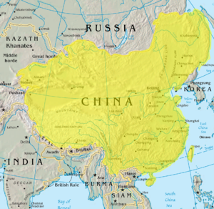
By the 1600s the Ming dynasty had grown weak and corrupt. As they declined, the Manchu people across the Great Wall were expanding, unifying a strong state and borrowing Chinese bureaucratic institutions. In 1644 the Manchus entered China and easily drove all the way to Beijing where they defeated the weakened Ming and established their own rule over China, the Qing Dynasty. The Qing Dynasty would be characterized by a problem some other land-based empires had in this time period—a minority ruling a different ethnic or religious majority. To bridge the gap between themselves and the ethnic Han Chinese, the Manchus implemented the civil service Confucian bureaucracy. Chinese were allowed to rise in the political system, and Qing Emperors adopted the Chinese title Son of Heaven. The Manchu emperors began the practice of publically performing Confucian rituals to gain political legitimization from the Chinese. For example, each year the Emperor would plow the first furrow of ground in front of the Temple of Agriculture (see below). This symbolic gesture was to ensure a good harvest. Most everything the emperor did was choreographed with Confucian ritual. The Manchu emperors continued these rituals. They also kept the classical Confucian texts as the basis of the civil service examination system. The Manchus utilized the nobles of conquered areas to help them administrate and control their growing empire. Buddhists and Muslim leaders, as well as Mongol aristocrats were given positions in the Qing. They respected local traditions by exempting Buddhist monks and monasteries from state labor service and taxes. They respected Mongol traditions by not allowing Chinese to migrate into Mongol territory and dilute Mongol culture. Indeed, the Qing respected Tibetan, Mongol and Buddhist culture, a practice that eased the expansion of the Qing Empire into new areas.
The Manchus outlined what is today the general boarders of China, and by respecting the cultures of minorities they preserved a sense of identity for many of these groups and endowed them with an enduring sense of autonomy (consider Tibet, for example). Despite the fact that ethnic Chinese were allowed to rise in the bureaucracy, the Manchus preserved the highest positions in the government for themselves. They maintained their cultural integrity by banning marriage between Manchus and Chinese. Han Chinese were forbidden to move into the Manchu homeland. They forced the Chinese to forgo the Ming style robs in favor of Manchu garments and ordered the Chinese to adopt the Manchu hair style of shaving the front of the head and braiding the long hair in the back into a queue. Much of what the Manchu accomplished resembled previous Chinese dynasties. They centralized rule through a bureaucracy. They expanded militarily far into central Asia and established tributary relations with Vietnam, Burma. Korea and Nepal. They focused China’s economic strength more on the practice of agriculture than they did commerce; the city of Canton in the south of China was the only location where trade with Europe was allowed. As new crops were transplanted from the New World, the Qing experienced a large population growth commensurate with their territorial growth. In some areas, silk production exceeded rice production and consumed all surplus labor of peasant families.

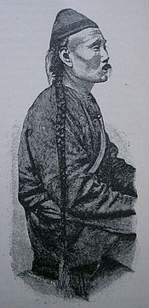
Manchus and their Chinese subjects
The Qing dynasty expanded Chinese territory larger than it ever had been before and ruled a population of 450 million people. Unlike previous Chinese dynasties, the Qing did not impose Chinese language or culture over their subjects and thought of China as just one part of a larger Manchu empire. They adopted a policy of "ruling different people differently," allowing local languages, customs, and in some cases, permitting local leaders to maintain leadership positions. Some groups had more privileges than others. Manchus, of course, were the most favored group but Chinese were allowed to take governing posts in the Confucian bureaucracy along with Manchus. The highest point to which a Chinese civil servant could rise was an executive position known as a "grand secretary." These administrators had no policy making power; however, they served as channels of communication "by ratifying, and forwarding 'memorials,' reports sent to the emperor from other central and field offices." The highest central administrative positions in Beijing, of course, were reserved for Manchus. Allowing Chinese to earn positions in the bureaucracy through civil service examinations rendered Manchu rule more acceptable for Chinese. And to prevent Chinese from dominating the bureaucracy, it was much easier for Manchus to gain appointments and rise through the ranks.

Chinese emperor's performance of Confucian rituals
Confucianism was always deeply concerned with rituals, and during the Tang dynasty leaders adapted Confucian rituals to legitimize their rule. Later, when the foreign Manchus established the Qing dynasty, they appropriated these rituals in an effort to claim the Mandate of Heaven and to elevate the importance of the emperor. Many Confucian rituals involved the imperial family. In fact, it is only a slight exaggeration to say that established rituals proscribed most everything the emperor did. For example, in the beginning of the spring the Emperor participated in an elaborate ceremony in which he plowed the first furrow of earth and planted the first seed in front of the Temple of Agriculture. No farm work could begin until the emperor completed this ritual. This ceremonial act procured the good will of the gods, ensured a plentiful harvest, and linked the vigor of Chinese civilization to the actions of the emperor. The Qing, who were not Chinese but Manchus, adopted this Confucian ritual to connect themselves to the tradition of Chinese emperors who preceded them. It was an act of legitimization. There were other ways the ruling dynasty used Confucian ritual to legitimize their rule. The sacrifices to Heaven, performed in the northern suburbs of the capital during the summer solstice and in the southern during the summer solstice, grew to be the most important rituals. Many rituals of ancestor worship were absorbed into the sacrifices made to Heaven thus creating a close link between the spirits of the ancestors and Heaven. In fact, the Emperor's ancestors became a link between Heaven and the imperial family. By publicly performing these rituals twice a year, the Emperor was reaffirming the Mandate of Heaven.

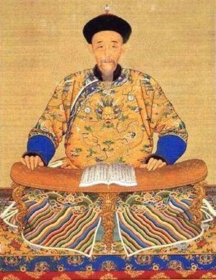
Qing imperial portraits
We saw above how important rituals were to the Chinese imperial court. During the Qing dynasty these ceremonies included the use of art. Imperial portraits of emperors adorned many of the palaces inside the Forbidden City and were an important part of funeral rituals when an emperor died. We see vestiges of ancestor veneration in the fact that some emperors performed ceremonies before portraits of previous leaders of their dynasty and even kowtowed to these portraits. In the public sphere, imperial portraits were utilized to enhance the legitimacy of the emperor. Portraits of emperor Kangxi, for example, often show him surrounded by books or holding a book in his hands, a representation that serves the imperial Confucian ideology that scholarship and command of knowledge merit legitimacy for an emperor. Legitimacy was a crucial factor for Emperor Kangxi. As a Manchu he needed to gain respect from ethnic Chinese; promoting himself as an accomplished scholar helped win the scholar bureaucrats and gain the Mandate of Heaven in the eyes of many Chinese.
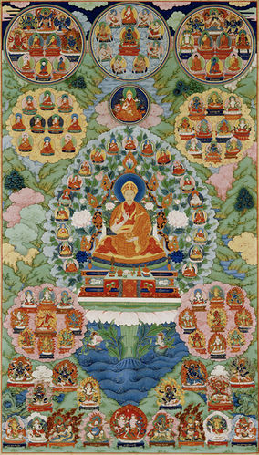
The Qianlong Emperor as the Bodhisattva Mafijusrt. During the reign of the Qianlong Emperor (1736-1796) the Qing dynasty expanded the borders of China farther than they had ever been before. China also became much more multi-cultural than it had ever been. The Qianlong Emperor used imperial portraits to represent himself to each region in the culture and dress of that region. To the ethnic Chinese (the Han) he had himself painted as a great scholar and promoter of Chinese values; to the Mongols of Central Asia, he was depicted as a traditional warrior of the steppes. The portrait above shows him pictured as the best known bodhisattva of Tibetan Buddhism, surrounded by Buddhist symbols. For example, he "raises his right hand in the gesture of argument while supporting the wheel of the law in his left. He also holds two stems of lotus blossoms, which serve as platforms for a sutra and a sword, the attributes of Manjusri. He is pictured among 108 deities . . . who represent his Buddhist lineage."

