Document 1
Those who are ignorant about government insistently say: "Win the hearts of the people." If order could be procured by winning the hearts of the people, then even the wise ministers Yi Yin and Kuan Chung would be of no use. For all that the ruler would need to do would be to listen to the people. Actually, the intelligence of the people is not to be relied upon any more than the mind of a baby.... The reason for the ruler to look for wise and well-informed men is that the intelligence of the people is not such as to be respected or relied upon. For instance, in ancient times, when Yu opened the rivers and deepened them, the people gathered tiles and stones (to hit him); when the prime minister of Cheng, Tzu Ch'an, cleared the fields and planted mulberry trees, the people of Cheng slandered and reviled him. Yu benefited the whole empire and Tzu Ch'an preserved the state of Cheng, but each incurred slander thereby. Clearly the intelligence of the people is not to be relied upon. Therefore, to seek for the worthy and the wise in selecting officials and to endeavor to suit the people inadministering the government are equally the cause of chaos and not the means for attaining order.
SOURCE: Chapter 50 in the Han Fei Tzu, by the Legalist scholar, Han Fei.

- How should a ruler deal with his subjects, according to Han Fei?

Document 2
...To govern the state by law is to praise the right and blame the wrong.
The law does not fawn {show extreme affection} on the noble....Whatever the law applies to, the wise cannot reject nor can the brave defy. Punishment for fault never skips ministers, reward for good never misses commoners. Therefore, to correct the faults of the high, to rebuke the vices of the low, to suppress disorders, to decide against mistakes, to subdue the arrogant, to straighten the crooked, and to unify the folkways of the masses, nothing could match the law....If penalty is severe, the noble cannot discriminate against the humble. If law is definite, the superiors are esteemed and not violated. If the superiors are not violated, the sovereign will become strong and able to maintain the proper course of government. Such was the reason why the early kings esteemed Legalism and handed it down to posterity {succeeding generations}. Should the lord of men discard law and practice selfishness, high and low would have no distinction.
SOURCE: Selection from the writings of Han Fei, a Legalist writer, 230 BCE.

- According to Han Fei, what is the purpose of law in governing a nation?

Document 3
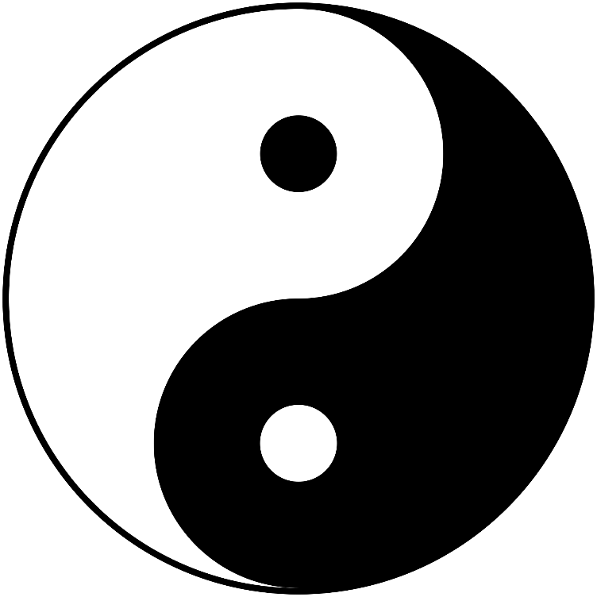
The Way produces the One. The One produces two. Two produces three. Three produces the myriad {many} creatures. The myriad creatures shoulder yin and embrace yang, and by blending these qi{vital energies} they attain harmony.... And so sometimes diminishing a thing adds to it; Sometimes adding to a thing diminishes it.... [Chapter 42]
SOURCE: Excerpts from Laozi [Lau Tzu], The Daodejing[Tao Te Ching].

- Identify the symbol illustrated above. What is the meaning behind this symbol for a follower of Daoism??

Document 4
....Manifest plainness. Embrace simplicity. Do not think just of yourself. Make few your desires. [Chapter 19]
...Those who make a display of themselves are not illustrious. Those who affirm their own views are not well known. Those who brag about themselves are not accorded merit. Those who boast about themselves are not heard of for long. From the point of view of the Way [Dao], such things are known as “excess provisions and pointless activities.” All creatures find these repulsive; And so one who has the Way does not abide in them. [Chapter 24]
...Streams and torrents flow into rivers and oceans, Just as the world flows into the Way. [Chapter 32]
SOURCE: Excerpts from Laozi’s, The Daodejing.

- List two key Daoist ideas. How does one seek the Dao [the Way]?

Document 5
In governing men and in serving heaven, there is nothing like moderation. For only by moderation can there be an early return to the normal state of humankind. This early return is the same as a great storage of virtue. With a great storage of virtue there is nothing that may not be achieved. If there is nothing that may not be achieved, then no one will know to what extent this power reaches. And if no one knows to what extent a man’s power reaches, that man is fit to be the ruler of a state...; practice non-interference in order to win the empire....
The greater the number of laws and enactments, the more thieves and robbers there will be. Therefore the Sage [Laozi] says: “So long as I do nothing, the people will right themselves. If only I keep from meddling, the people will grow rich. If only I am free from desire, the people will come naturally back to simplicity....
SOURCE: The Sayings of Lao Tzu, translated by Lionel Giles.

- According to Daoism, how should a ruler govern?

