Name:______________________________________Date:_________Period:____

**DBQ: Mesopotamia and Egypt**

**Directions:**

The task below is based on documents 1 through 6. This task is designed to test your ability to work with the information provided by various types of documents. Look at each document and answer the questions after each document. You will use your answers to these questions to help you answer the broader question below.

**Background:**

The Ancient cultures of Egypt and Mesopotamia helped to develop civilization today. Ancient Egyptians developed a civilization in northeastern Africa in the Nile River valley. Ancient Egypt was an advanced civilization in many areas, including religion, architecture, transportation, and trade. Ancient Mesopotamia was one of the first civilizations that developed a form of government as well as organized people into political states.

**Question:**

How did the ancient cultures of Mesopotamia and Egypt develop into successful civilizations?

**Document 1:**

*Source: Ancient Egyptian Song about the Nile*

“When the [Nile] arises earth rejoices and all men are glad … That givest drink to the desert places which are far from water.”

1. According to the song, what were two effects of the Nile’s rising waters?

______________________________________________________________________________________

______________________________________________________________________________________

______________________________________________________________________________________

______________________________________________________________________________________

1. Why was the Nile so important to the Egyptians?

______________________________________________________________________________________

______________________________________________________________________________________

______________________________________________________________________________________

______________________________________________________________________________________

**Document 2:**

*Source: Map of Mesopotamia and the Fertile Crescent*



1. Why were the Tigris and Euphrates Rivers so important for the survival and development of civilization?

______________________________________________________________________________________

______________________________________________________________________________________

______________________________________________________________________________________

______________________________________________________________________________________

1. Based upon the map, what is surrounding the Fertile Crescent in the South and in the East?

______________________________________________________________________________________

______________________________________________________________________________________

______________________________________________________________________________________

______________________________________________________________________________________

**Document 3:**

*Source: From and Egyptian Tomb, description of a Pharaoh.*

“[A pharaoh] is a god by whose dealings on lives, the father and mother of all… without an equal.”

1. Based on the quotation, what did ancient Egyptians believe made the pharaoh such a special person?

______________________________________________________________________________________

______________________________________________________________________________________

______________________________________________________________________________________

______________________________________________________________________________________

1. What type of power did the pharaoh possess in Egypt?

______________________________________________________________________________________

______________________________________________________________________________________

______________________________________________________________________________________

______________________________________________________________________________________

**Document 4:**

*Source: The Code of Hammurabi. The stated goal for his code of laws.*

“to render good to the people, to make justice shine in the land, to destroy the evil and the wicked, that the strong do not oppress the weak.”

1. Name **three** things Hammurabi wanted to accomplish with this set of laws.

______________________________________________________________________________________

______________________________________________________________________________________

______________________________________________________________________________________

______________________________________________________________________________________

1. How were people punished for stealing during Hammurabi’s time?

______________________________________________________________________________________

______________________________________________________________________________________

______________________________________________________________________________________

______________________________________________________________________________________

**Document 5:**

*Source: Diagram of an Egyptian Pyramid*



1. Where was the pharaoh’s chamber located?

______________________________________________________________________________________

______________________________________________________________________________________

______________________________________________________________________________________

______________________________________________________________________________________

1. Why do you think a temple was included outside the burial pyramid?

______________________________________________________________________________________

______________________________________________________________________________________

______________________________________________________________________________________

______________________________________________________________________________________

**Document 6:**

*Source: Illustration of a Sumerian Ziggurat*

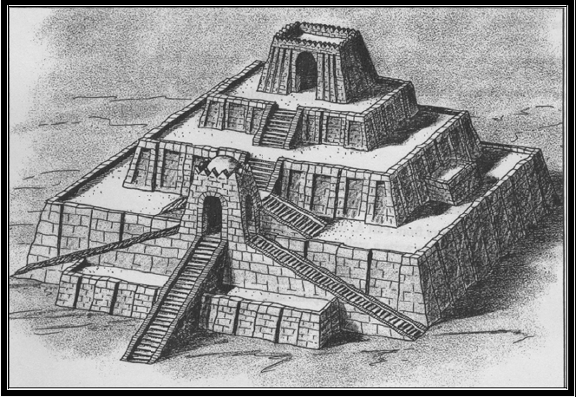

1. Look at the illustration. Notice the number of stairs. What does the size of the temple tell you about the value Sumerians placed on their gods?

______________________________________________________________________________________

______________________________________________________________________________________

______________________________________________________________________________________

______________________________________________________________________________________

1. From the image above, what did the Sumerians and Akkadians look to their gods for?

______________________________________________________________________________________

______________________________________________________________________________________

______________________________________________________________________________________

______________________________________________________________________________________