THE BLACK DEATH

Overview
- The diffusion of crops and pathogens, including epidemic diseases like the bubonic plague, often occured along trade routes.
- The bubonic plague - named the Black Death by later historians - was caused by the yersinia pestis bacteria, which lived in rodent populations and was spread by fleas that had bitten infected animals.
- Once the plague transferred to animals that were in close contact with humans and to humans themselves, it began to spread along established trade routes.
- It is difficult to measure the exact human cost of the plague due to limited records from the historical period.
- Most historians think that the plague killed somewhere between 30% and 60% of Europe’s population between 1347 and 1351.

Trade and disease
The spread of disease and trade went hand in hand, and no event illustrates this relationship better than the outbreak of bubonic refers to the swollen lymph nodes, which were called "buboes"plague in the mid-14th century, an event more commonly known today as the Black Death.
In a passage from his book titled The Decameron, Florence, Italy resident Giovani Boccaccio described the Black Death, which reached Florence in 1348:
It first betrayed itself by the emergence of certain tumors in the groin or the armpits, some of which grew as large as a common apple, others as an egg, some more, some less . . . From the two said parts of the body this deadly [bubo] soon began to propagate and spread itself in all directions indifferently; after which the form of the malady began to change, black spots or livid making their appearance in many cases on the arm or the thigh or elsewhere, now few and large, then minute and numerous.
Historians and epidemiologists people who study the spread of diseases are confident that the Black Death originated in east-central Asia, which raises the question: How did the plague make it to Europe? To understand how the plague spread, we need to understand how the disease was transmitted, along with the broader economic and political contexts that made its spread possible.

Origins of the plague outbreak
The bacterium that causes the bubonic plague is called yersinia pestis. It can survive in rodent populations and is spread to other mammals, including humans, through flea bites. The point of origin for the Black Death was most likely a population of marmots—small, prairie-dog like rodents—in Central Asia.
Marmots generally avoid contact with humans, but rats will readily come in contact with both marmot and human populations. Rats also carry fleas, making them an ideal vehicle—from the perspective of the plague, at least—for spreading the bubonic plague.
The plague caused an epidemic in China in the 1330s, and again in the 1350s, causing tens of millions of deaths. The 1330s outbreak also spread west across Central Asia via traders using the Silk Road.
Historian William McNeill argued that caravanserai - rest stops for traders - facilitated the spread of the disease as traders and their animals interacted in close quarters. That proximity provided new hosts for the disease, who then carried it to new locations, repeating the process of introducing and spreading the plague along overland trade routes.

The plague spreads
By the 1300s, several Italian city-states had established trade relationships throughout the Mediterranean and Black Seas. The Genoese had a successful colony at the city of Kaffa on the Crimean Peninsula, which they held with the permission of the Mongol rulers of the region. In 1344, disagreements between the Genoese and the Mongols led to conflict.
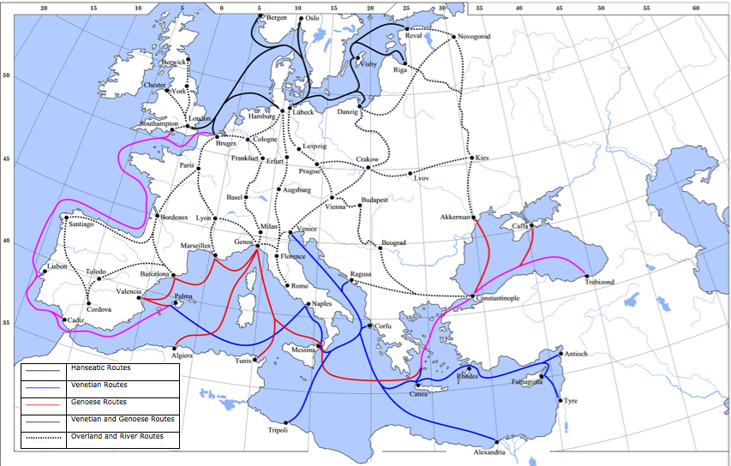
Note how much of Europe was linked via trade routes. Compare the map below showing the spread of plague to the routes shown here to see how the plague spread north from the Mediterranean ports.
In 1346, the plague reached the Mongol soldiers who were besieging the city of Kaffa. Stories from the period tell us that the plague devastated the Mongol army, forcing it to give up the siege. Some of these stories also include a more gruesome detail: the Mongols catapulted the dead bodies of the soldiers who died of the plague into the city.
Whether the Mongols intended to spread the disease, and whether the story is even true, is not clear. What is clear is that some residents of Kaffa were infected with plague.
The plague continued to travel through Asia, eventually hitting major cities such as Baghdad and Constantinople. From there, it traveled to Alexandria in Egypt, Damascus in Syria, and down the Red Sea to Mecca. From there it almost certainly entered the Indian Ocean trade networks. The plague also traveled with Genoese merchants back to Italy, first to the port of Messina in 1347, and then north through Europe over the next several years.
The first cases of plague in Europe were spread by Genoese traders returning from Kaffa. Note that the earliest areas of plague were around Constantinople and in the islands of Sicily, Sardinia, and Corsica, and also the port of Marseille. All of these would have been stops for Genoese ships on their way from Crimea to Genoa. (Genoa is on the coast roughly between Marseille and Milan.)

Effects of the plague
Most in-depth studies of the Black Death focus on Europe, but this is a result of the available source material and what historians have chosen to study, rather than any major differences in its severity or impact between Europe and Asia.
After all, Europe had a smaller population than China. In terms of deaths, it is likely the plague did more damage in China. Given the large volume of trade in the Indian Ocean, it is not surprising to find accounts that hint at the plague spreading throughout the Middle East and South Asia at this time as well.
Although the lack of clear records makes it hard to be precise, historians generally estimate the Black Death killed between 30% and 60% of Europe’s population between 1347 and 1351. However, death rates varied from place to place. Some areas saw mortality of 80% or higher, while other places remained almost untouched by the disease.
Whatever the actual numbers, the massive loss of population - both human and animal - had major economic consequences. Those cities hit with the plague shrank, leading to a decrease in demand for goods and services and reduced productive capacity.
As laborers became more scarce, they were able to demand higher wages.
This had several major effects:
- Serfdom began to disappear as peasants had better opportunities to sell their labor.
- High labor costs caused landowners to look for more efficient and profitable ways to use their land and resources, such as increasing livestock production and payments of rent in money, rather than labor.
- High labor costs also caused governments to impose price controls on wages, but these efforts were often unsuccessful and sometimes met with rebellion.
- The fear and confusion caused by the plague sometimes led to violence, in part because of a lack of medical knowledge regarding how the plague spread. Jews, Romani a traditionally nomadic ethnic group, sometimes called gypsies, lepers people afflicted with leprosy, a disease caused by bacteria that leads to nerve damage and skin lesions; lepers were often forced to live in separate communities in the medieval period, and other religious and cultural minorities were sometimes blamed for causing or spreading the plague and became targets of attacks. It should be noted that the plague did not cause these social tensions, but rather created a context that made these tensions stronger and more likely to lead to violence.

Conclusion
Although today we understand the medical aspects of the plague in ways that fourteenth century people could not, as historians we consider how the people who lived through it understood the plague and what impact it had on their actions.
From the broader perspective of world history, the real takeaway from the Black Death is how the vast, interconnected trading networks that existed at this time made the spread of a disease like plague possible in the first place, and how it dramatically altered the local communities it infected.
The expansion of trade brought many benefits, increasing access to material goods and technology, as well as spreading knowledge. However, the plague illustrates how increased cross-cultural contacts along denser trade networks increased the potential damage that could be caused by disease.
It was not a coincidence that the plague outbreak in the mid-fourteenth century did more damage than the outbreak in the mid-sixth century. Rather, the greater devastation occurred because the world of the mid-fourteenth century was more connected through trade.

