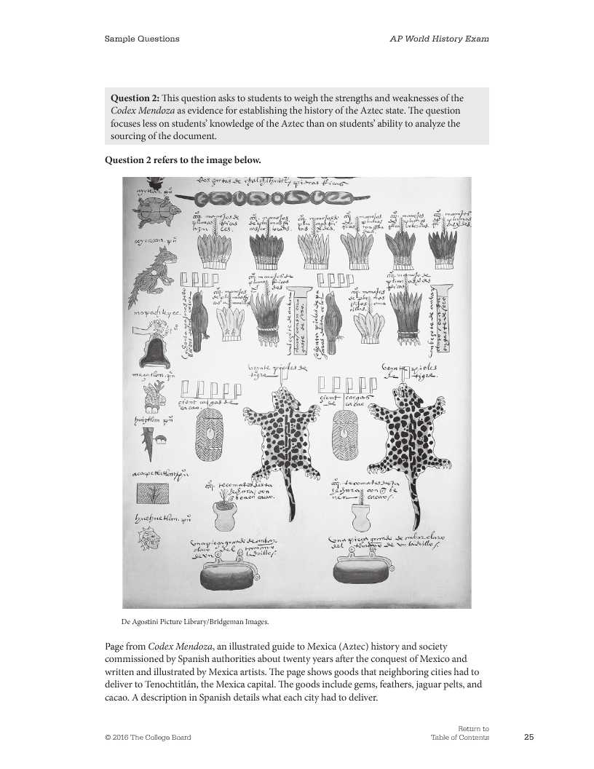
Answers parts a and b
a) Identify and explain TWO historical claims about the Aztec state that can be supported based on the image
b) Identify ONE limitation of the image as a source of information about the Aztec

