AP World History
Survival Guide

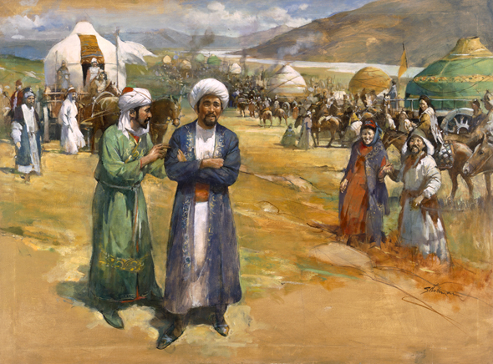

Table of Contents
 | Pages
AP World History Overview | 3 – 7
The AP Exam | 3
World Regions | 4 – 5
Five Course Themes | 6
Four Historical Thinking Skills | 7
AP Curriculum Framework | 21 – 38
Period 1 (Up to 600 B.C.E.)—5% | 21 – 22
Period 2 (600 B.C.E. to 600 C.E.)—15% | 23 – 25
Period 3 (600 to 1450)—20% | 26 – 28
Period 4 (1450 to 1750)—20% | 29 – 31
Period 5 (1750 to 1900)—20% | 32 – 35
Period 6 (1900 to the present)—20% | 36 – 38
Help with Some Confusing Subjects | 39 – 43
Chinese Dynasties | 39
Political, Economic, and Social Systems | 40
Religions | 41
Primary Sources | 42
“Must Know” Years | 43

- Many of the guidelines in this study packet are adapted from the AP World History Course Description, developed by College Board.
The AP Exam
Purchasing and taking the AP World History exam are requirements of the course. This year, the AP World History exam will be administered on: ___________________________________________
Format
- Multiple Choice
  - You will have 55 minutes to answer 70 Questions.
  - Each question has options A, B, C, and D.
  - Questions are divided evenly between the five course themes (20% each) and six periods.
  - Each questions addresses one of the four historical thinking skills.
  - You should answer ALL 70 questions, even if you have to guess. There are no points off for wrong answers.
- Free-Response Questions (FRQ’s)
  - Timing: Section II will begin with a ten minute reading period, followed by a 120 minute (2 hour) writing period, for a total of 2 hours and 10 minutes. During this section, students may distribute their time as they choose between the three questions; however, the proctor will issue time warnings suggesting you move on to the next question.
  - Part A: Document-Based Question
    - Suggested planning and writing time= 50 minutes
    - This essay question tests your ability to formulate and support an answer using documentary evidence. You will read, analyze, and group a selection of 7-10 primary source documents to craft and support a historical argument. You must use ALL the documents.
  - Part B: Change and Continuity over Time Question
    - Suggested planning and writing time= 40 minutes
    - This essay question deals specifically with analysis of changes and continuities over time and covers at least one of the periods in the concept outline. You should answer the question using specific evidence.
  - Part C: Comparative Question
    - Suggested planning and writing time= 40 minutes
    - The comparative essay focuses on developments across at least TWO regions or societies. It relates to one of the five major themes in the course (ex: state building, economic systems) and requires analysis of the reasons for identified similarities and differences.
  - Essay Scoring: Students can earn a maximum of 9 points (7 basic core plus two expanded) on each essay, for a maximum essay score of 27 points.
- Exam Scoring
  - Each Section is given equal weight and then added together for a cumulative raw score, which then falls into one of five possible ranges. 5= Extremely well-qualified; 4= Well-Qualified, 3= Qualified, 2= Possibly Qualified, 1= No Recommendation.
  - Scores of 3, 4, and 5 are considered “passing” or “qualifying” scores and may earn students college credit.
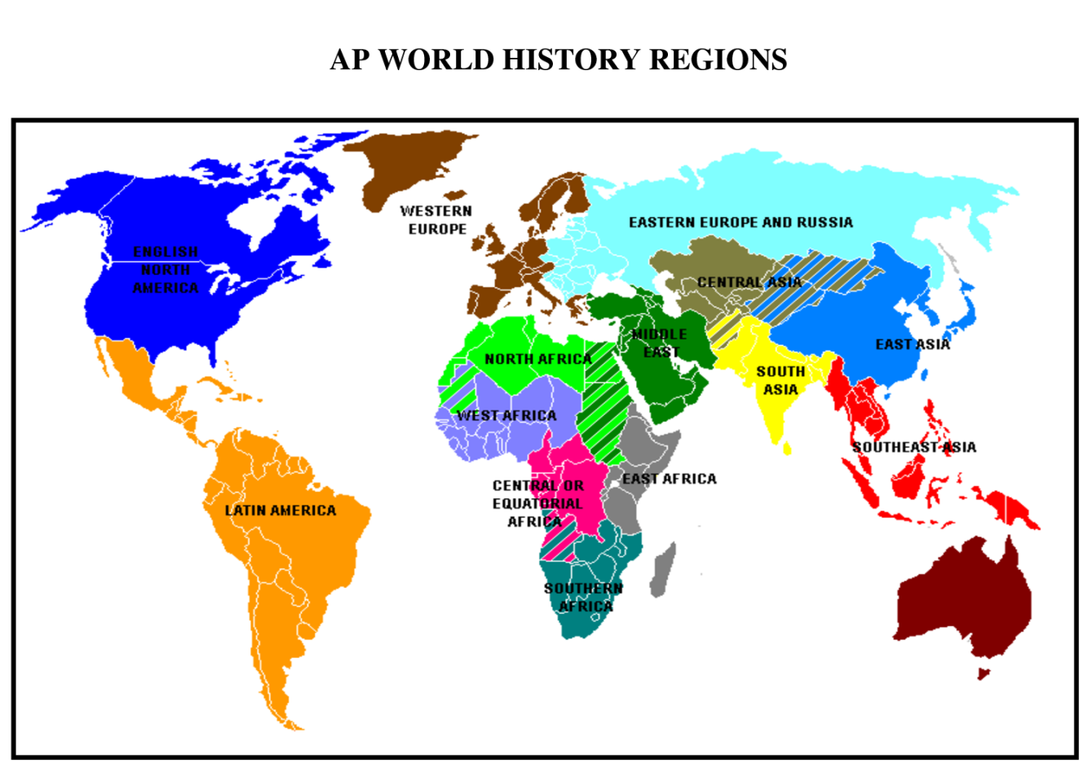
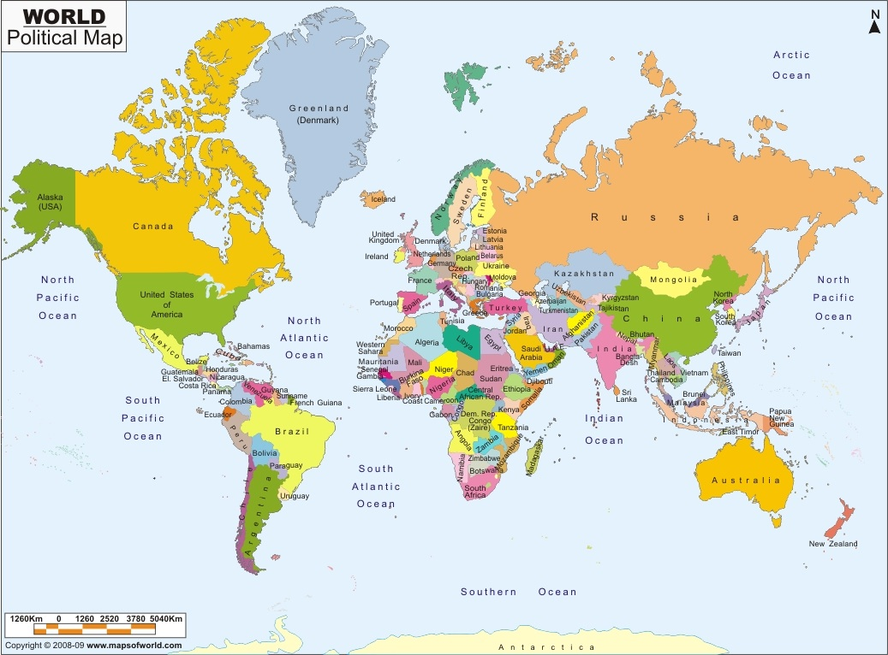
Regions Overview

Region | Past Major States and Empires | Current Nations (Examples)
North America | Cahokia, Iroquois Confederation  British and French colonization | United States, Canada
Latin America and the Caribbean | Olmec, Chavin, Maya, Aztec, Inca  Spanish and Portuguese colonization | Mexico, Cuba, Brazil, Venezuela, Columbia, Argentina
Western Europe | Roman Empire, Holy Roman Empire  Napoleonic Empire | United Kingdom, France, Germany, Italy, Spain, Portugal
Eastern Europe & Russia | Roman Empire, Byzantine Empire, Kievan Rus, Mongols, Soviet Union | Russia, Ukraine, Poland, Hungary, Bulgaria
South Asia | Indus Valley, Mauryan and Gupta Empires, Delhi sultanate, Mughal Empire, British India | India, Pakistan, Bangladesh,  Sri Lanka
East Asia | Chinese Dynasties, Korean kingdoms, Tokugawa Japan, Imperial Japan | China, Taiwan, Japan  North Korea, South Korea
Southeast Asia | Kingdom of Srivijaya, city-states (Malacca), Dutch Indonesia | Indonesia, Malaysia, Thailand, Cambodia, Vietnam, Burma
Central Asia | Mongol Empire | Mongolia
The Middle East | Roman Empire, Abbasid & Umayyad Caliphates, Ottoman Empire | Egypt, Turkey, Iran, Iraq, Syria, Saudi Arabia, Israel
North Africa | Carthage, Roman Empire, Ottoman Empire, Caliphates, French Algeria | Libya, Algeria, Tunisia
Sub-Saharan Africa
West Africa | Ghana, Mali, Songhay  British & French colonization | Ghana, Nigeria
East Africa | Axum, Kingdom of Ethiopia, Swahili city-states; European colonization | Tanzania, Kenya, Somalia
Central Africa | Great Zimbabwe, Belgian Congo | Democratic Republic of Congo, Rwanda
Southern Africa | Zulu Kingdom, European colonization | South Africa

COURSE THEMES

Course Acronym= SPICE
- Social (Theme 5)
- Political (Theme 3)
- Interaction with the Environment (Theme 1)
- Cultural (Theme 2)
- Economic (Theme 4)
Theme #1: Human Interaction with the Environment (Geography)
- Interaction between humans and the environment
- Demography and disease
- Migration
- Patterns of settlement
- Technology
Theme #2: Development and interaction of cultures
- Religions
- Belief systems, philosophies, and ideologies
- Science and technology
- The arts and architecture
Theme #3: State-building, expansion, and conflict
- Political structures and forms of governance
- Empires
- Nations and nationalism
- Revolts and revolutions
- Regional, transregional, and global structures and organizations
Theme #4: Creation, expansion, and interaction of economic systems
- Agricultural and pastoral production
- Trade and commerce
- Labor systems
- Industrialization
- Capitalism and socialism
Theme #5: Development and transformation of social structures
- Gender roles and relations
- Family and kinship
- Racial and ethnic constructions
- Social and economic classes

Four Historical Thinking Skills
- Crafting Historical Arguments from Historical Evidence:
  - Historical Argumentation: Historical thinking involves the ability to define and frame a question about the past and to address that question through the construction of an argument. A plausible and persuasive argument requires a clear, comprehensive and analytical thesis.
  - Appropriate Use of Relevant Historical Evidence: Arguments must be supported by relevant historical evidence — not simply evidence that supports a preferred or preconceived position. Additionally, argumentation involves the capacity to describe, analyze, and evaluate the arguments of others in light of available evidence.

- Chronological Reasoning
  - Historical Causation: Historical thinking involves the ability to identify, analyze, and evaluate the relationships between multiple historical causes and effects, distinguishing between those that are long-term and proximate, and among coincidence, causation, and correlation.
  - Patterns of Continuity and Change over Time: Historical thinking involves the ability to recognize, analyze, and evaluate the dynamics of historical continuity and change over periods of time of varying length, as well as relating these patterns to larger historical processes or themes.
- Periodization: Historical thinking involves the ability to describe, analyze, evaluate, and construct models of historical periodization that historians use to categorize events into discrete blocks and to identify turning points, recognizing that the choice of specific dates privileges one narrative, region or group over another narrative, region or group; therefore, changing the periodization can change a historical narrative.

- Comparison and Contextualization
  - Comparison: Historical thinking involves the ability to describe, compare, and evaluate multiple historical developments within one society, one or more developments across or between different societies, and in various chronological and geographical contexts.
  - Contextualization: Historical thinking involves the ability to connect historical developments to specific circumstances of time and place, and to broader regional, national, or global processes.

- Historical Interpretation and Synthesis
  - Interpretation: Historical thinking involves the ability to describe, analyze, evaluate, and create diverse interpretations of the past — as revealed through primary and secondary historical sources — through analysis of evidence, reasoning, contexts, points of view, and frames of reference.
  - Synthesis: Historical thinking involves the ability to arrive at meaningful and persuasive understandings of the past by applying all of the other historical thinking skills, by drawing appropriately on ideas from different fields of inquiry or disciplines and by creatively fusing disparate, relevant (and perhaps contradictory) evidence from primary sources and secondary works. Additionally, synthesis may involve applying insights about the past to other historical contexts or circumstances, including the present.

AP Curriculum Framework

PERIOD 1: UP TO 600 BCE

Key Concept 1.1. Big Geography and the Peopling of the Earth – Paleolithic Era

I. Paleolithic Era: Archeological evidence shows that during the Paleolithic era, hunting-foraging bands of humans gradually migrated from their origin in East Africa to Eurasia, Australia, and the Americas, adapting their technology and cultures to new climates.
A. Humans used fire to aid hunting, protect against predators, and adapt to cold environments.
B. Humans developed a wider range of tools specially adapted to different environments.
C. Economic structures focused on small kinship (family) groups of hunting foraging bands that could make what they needed to survive. However, not all groups were self-sufficient; they exchanged people, ideas, and goods.

Key Concept 1.2. The Neolithic Revolution and Early Agricultural Societies – Neolithic Era

I. Neolithic Revolution: Beginning around 10,000 years ago, the Neolithic Revolution resulted in the development of new and more complex economic and social systems.
A. Possibly as a response to climatic change, permanent agricultural villages emerged first in the lands of the eastern Mediterranean. Agriculture emerged at different times in Mesopotamia, the Nile River Valley and Sub-Saharan Africa, the Indus River Valley, the Yellow River or Huang He Valley, Papua New Guinea, Mesoamerica, and the Andes.
B. Pastoralism (herding) developed at various sites in the grasslands of Afro- Eurasia.
C. Different crops or animals were domesticated in the various core regions.
D. Agricultural communities worked cooperatively to clear land and create water control systems (irrigation) needed for crop production.
E. These agricultural practices drastically impacted environmental diversity. Pastoralists also affected the environment by grazing large numbers of animals on fragile grasslands, leading to erosion when overgrazed.

II. Agriculture and pastoralism began to transform human societies.
A. Pastoralism and agriculture led to more reliable and abundant food supplies, which increased the population.
B. Surpluses of food and other goods led to specialization of labor, including new classes of artisans and warriors, and the development of elites.
C. Technological innovations led to improvements in agricultural production, trade, and transportation.
Examples: pottery, plows, woven textiles, metallurgy, wheels and wheeled vehicles
D. In both pastoralist and agrarian societies, elite groups accumulated wealth, creating more hierarchical (unequal) social structures and promoting patriarchal (male-dominated) forms of social organization.

Key Concept 1.3. Development and Interactions of Early Agricultural, Pastoral, & Urban Societies—Early Civilizations
I. Core civilizations developed in a variety of geographical and environmental settings where agriculture flourished. Examples:
Mesopotamia in Tigris/Euphrates River Valleys; Egypt in Nile River Valley
Mohenjo-Daro and Harappa in Indus River Valley, Shang in the Huang He Valley
Olmec in Mesoamerica; Chavin in Andean South America

II. The first states emerged within core civilizations.
A. States were powerful new systems of rule that mobilized surplus labor and resources over large areas. Early states were often led by a ruler whose source of power was believed to be divine or had divine support and/or who was supported by the military.
B. As states grew and competed for land and resources, the more favorably situated — including the Hittites, who had access to iron — had greater access to resources, produced more surplus food, and experienced growing populations. These states were able to undertake territorial expansion and conquer surrounding states.
C. Early regions of state expansion or empire building: Mesopotamia, Babylonia, and the Nile Valley.
D. Pastoralists were often the developers and disseminators of new weapons and modes of transportation that transformed warfare in agrarian civilizations.
Examples: Compound bows, iron weapons, chariots, horseback riding

III. Culture: Culture played big role in unifying states with laws, language, literature, religion, myths, and monumental art.
A. Early civilizations developed monumental architecture and urban planning.
Examples: ziggurats, pyramids, temples, defensive walls, roads, sewage/water systems

B. Elites, both political and religious, promoted arts and artisanship.
Examples: sculpture, painting, wall decorations, weaving.
C. Systems of record keeping arose in all early civilizations & diffused.
Examples: cuneiform, pictographs, hieroglyphs, alphabets, quipu
D. States developed legal codes (like Code of Hammurabi) reflecting existing hierarchies & facilitating rule of governments.
E. New religious beliefs developed in this period continued to have strong influences in later periods.
Examples: The Vedic religion (Hinduism); Hebrew monotheism (Judaism); Zoroastrianism
F. Trade expanded throughout this period from local to regional and transregional, with civilizations exchanging goods, cultural ideas, and technology.
Examples: Between Egypt and Nubia; Between Mesopotamia and the Indus Valley
G. Social and gender hierarchies intensified as states expanded and cities multiplied.
H. Literature was also a reflection of culture.
Examples: The Epic of Gilgamesh, Rig Veda, Book of the Dead
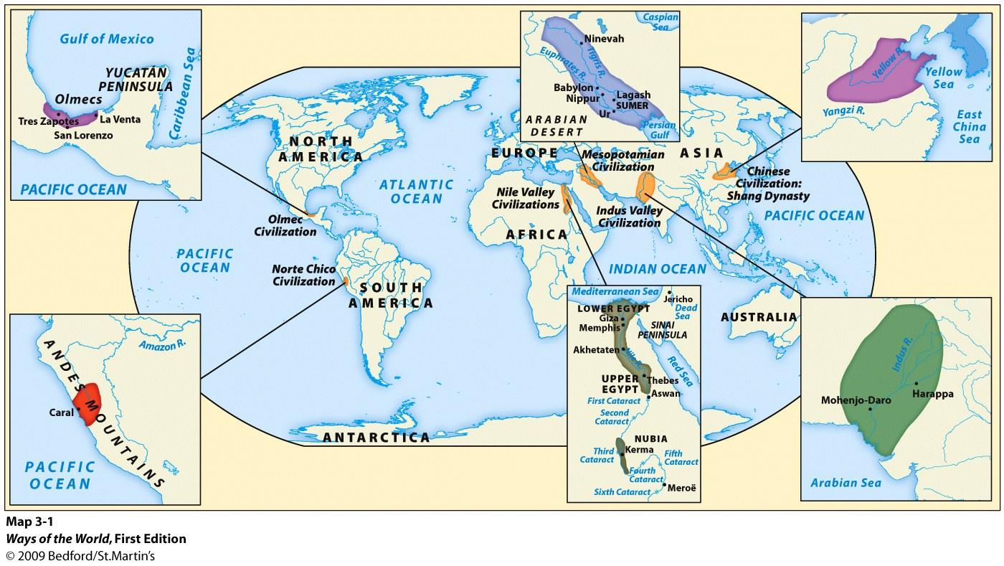
PERIOD 2: 600 BCE to 600 CE
Key Concept 2.1. The Development and Codification of Religious and Cultural Traditions

I. Codifications (writing down) and development of existing religions provided a bond among the people and an ethical code to live by.
A. Judaism: The association of monotheism w/ Judaism was further developed with the codification of the Hebrew Scriptures, which also reflected the influence of Mesopotamian cultural and legal traditions. The Assyrian, Babylonian, and Roman empires conquered various Jewish states at different points in time, resulting in Jewish diasporic communities in Mediterranean & Mideast.
B. Hinduism: The core beliefs outlined in the Sanskrit scriptures formed the basis of the Vedic religions — later known as Hinduism — which contributed to the development of the social and political roles of a caste system and in the importance of multiple manifestations of Brahma to promote teachings about reincarnation.

II. New belief systems & cultural traditions emerged and spread, often asserting universal truths.
A. Buddhism: The core beliefs about desire, suffering, and the search for enlightenment preached by the historic Buddha and recorded by his followers into sutras and other scriptures were, in part, a reaction to the Vedic beliefs and rituals dominant in South Asia. Buddhism changed over time as it spread throughout Asia — first through the support of the Mauryan Emperor Ashoka, then through missionaries and merchants, and the establishment of educational institutions to promote its core teachings (monasteries).
B. Confucianism: Core beliefs and writings originated in writings and lessons of Confucius, and were elaborated by disciples; sought to promote social harmony by outlining proper rituals and social relationships for all people in China, including the rulers.
C. Daoism: In the major Daoist writings, core belief of balance between humans and nature assumed Chinese political system would be altered indirectly. Daoism also influenced the development of Chinese culture. Examples: Medicine, Poetry, Metallurgy, Architecture
D. Christianity: Based on core beliefs about teachings & divinity of Jesus as recorded by disciples; drew on Judaism; initially rejected Roman/Hellenistic influences. Despite initial Roman imperial hostility, Christianity spread through efforts of missionaries and merchants to many parts of Afro-Eurasia, and eventually gained Roman imperial support (Emperor Constantine).
E. Greco-Roman rationalism: Core ideas in philosophy/science emphasized logic, observation, nature of political power and hierarchy.

III. Belief systems affected gender roles. Buddhism & Christianity encouraged monastic life (living apart from society as monks/nuns) and Confucianism emphasized filial piety (respect for elders, parents, and ancestors).

IV. Other religious and cultural traditions continued parallel to the codified belief systems.
A. Shamanism and animism continued to shape the lives of people within and outside of core civilizations because of their daily reliance on the natural world.
B. Ancestor veneration persisted in Africa, East Asia, and the Andes.

V. Artistic expressions show distinctive cultural developments.
A. Literature and drama acquired distinctive forms that influenced artistic developments in neighboring regions and in later time periods. Examples: Greek plays, Indian epics
B. Distinctive architectural styles developed in many regions in this period.
Examples: India, Greece, Roman Empire, Mesoamerica

C. The blending of Greco-Roman culture and Buddhist beliefs led to unique sculptural developments (the Gandhara Buddha’s); this is an example of syncretism (blending two different cultures together).

Key Concept 2.2. The Development of States and Empires

I. States and Empires: The number and size of key states and empires grew dramatically by imposing political unity on areas where previously there had been competing states.
Examples: Mediterranean region: Phoenicia & colonies, Greek city-states & colonies, and Hellenistic and Roman Empires; SW Asia: Persian Empires (Achaemenid, Parthian, Sassanid); East Asia: Qin, Han; South Asia: Maurya, Gupta; Mesoamerica: Teotihuacan, Maya city-states; Andes: Moche

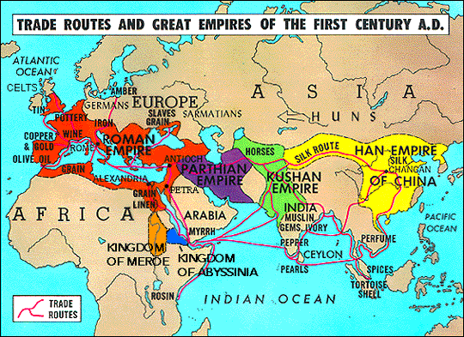

II. Empires & states developed new techniques of imperial administration based in part on success of earlier political forms.
A. Rulers created administrative institutions to rule subjects.
Examples: centralized governments, legal systems, bureaucracies
B. Imperial governments projected military power over larger areas using a variety of techniques.
Examples: diplomacy, supply lines, defensive walls, roads; drawing new groups of military officers
& soldiers from local populations or conquered peoples
C. Much of the success of the empires rested on their promotion of trade and economic integration by building and maintaining roads and issuing currencies.
Examples: China, Persia, Rome, South Asia

III. Unique social and economic dimensions developed in imperial societies.
A. Cities served as centers of trade, public performance of religious rituals, and political administration.
Examples: Persepolis, Chang’an, Athens, Carthage, Rome, Constantinople, Teotihuacan
B. Social hierarchies included cultivators, laborers, slaves, artisans, merchants, elites, or caste groups.
C. Societies relied on a range of methods to maintain the production of food and provide rewards for the loyalty of the elites.
Examples: Corvée, Slavery, Rents and tributes, Peasant communities
D. Patriarchy continued to shape gender and family relations in all imperial societies of this period

IV. Decline and Fall: The Roman, Han, Persian, Mauryan, and Gupta empires created political, cultural, and administrative difficulties that they could not manage, leading to their decline and collapse.
A. Through excessive mobilization of resources, imperial governments caused environmental damage, social tensions, and economic difficulties, resulting in too much wealth in the hands of elites.
Examples: Deforestation, Desertification, Soil erosion, Silted rivers

B. External problems resulted from security issues along their frontiers, including the threat of invasions: Han China & Xiongnu (Huns); Gupta and the White Huns; Romans and their N/E neighbors.

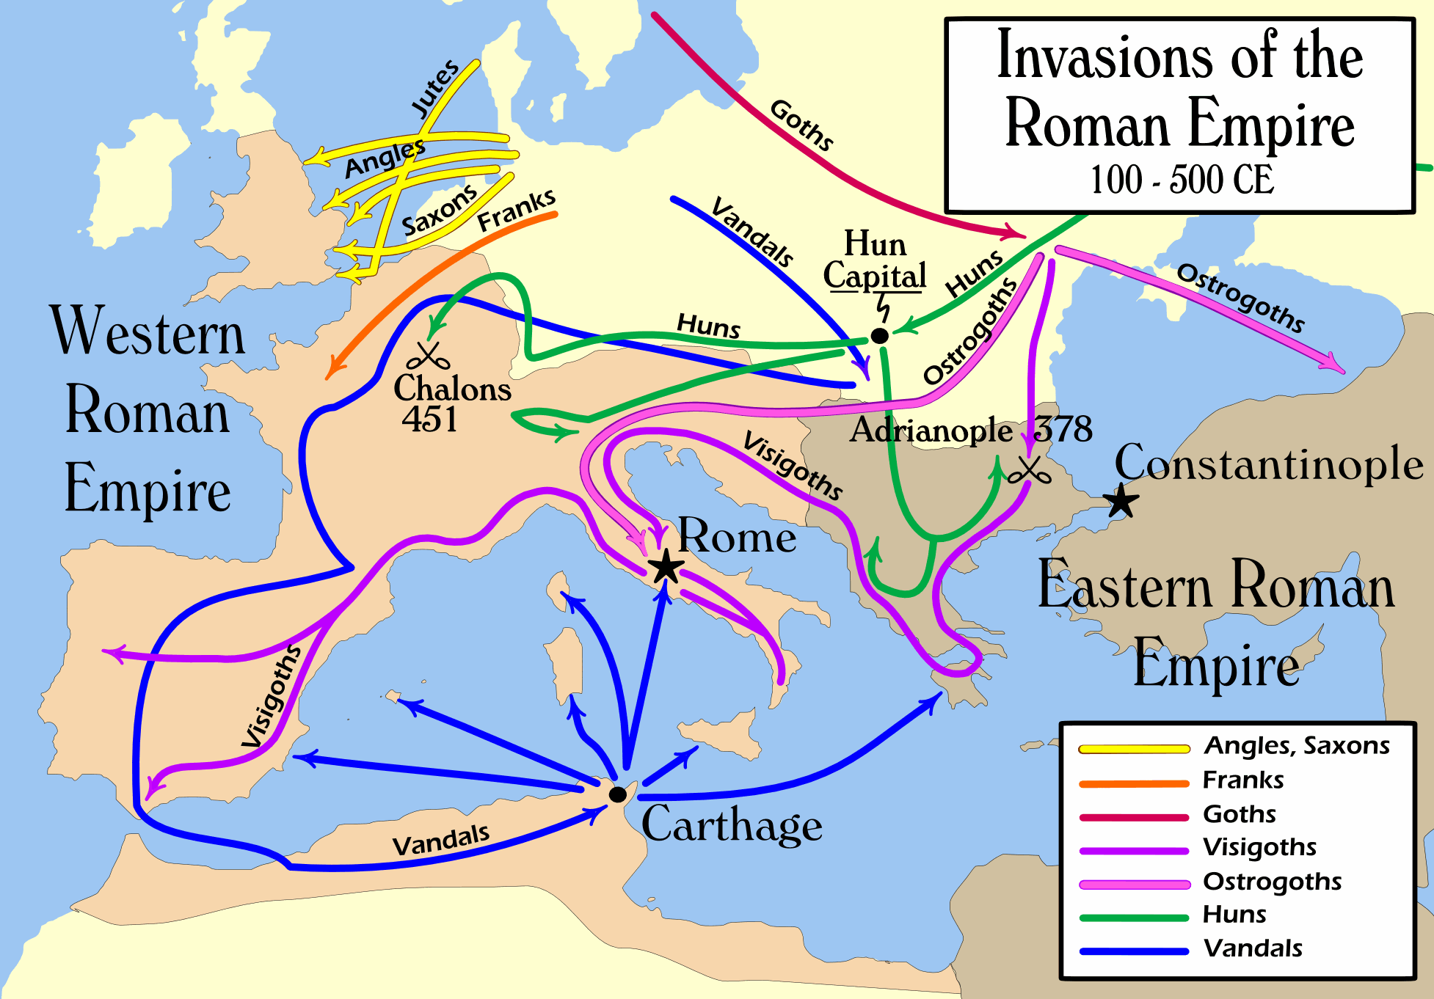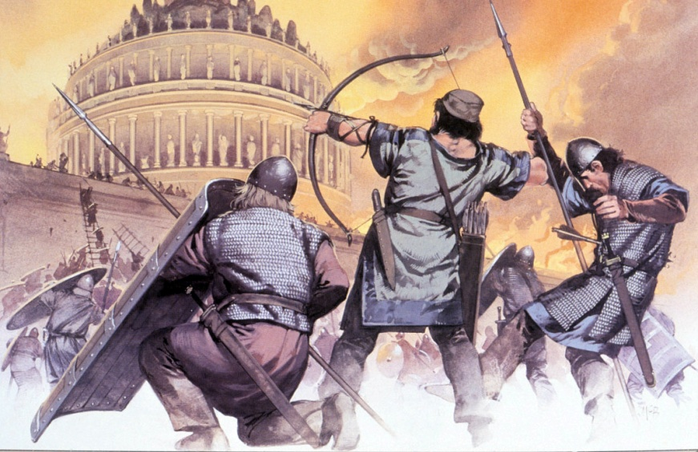

Key Concept 2.3. Emergence of Transregional Networks of Communication and Exchange

I. Emergence of Trade Routes: Land and water routes became the basis for transregional trade, communication, and exchange.
A. Many factors, including the climate and location of the routes, the typical trade goods, and the ethnicity of people involved, shaped the distinctive features of a variety of trade routes.
Examples: Silk Roads, Trans-Saharan trade, Mediterranean Sea, Indian Ocean

II. Technologies: New technologies facilitated long-distance communication and exchange.
A. Use of domesticated pack animals. Ex: Yokes, Saddles, Stirrups, Horses, Oxen, Llamas, Camels

B. Innovations in maritime technologies, as well as advanced knowledge of the monsoon winds, stimulated exchanges along maritime routes from East Africa to East Asia. Ex: Lateen sail; Dhow ships

III. Diffusion: Exchange of people, technology, religious/cultural beliefs, crops, domesticated animals, disease pathogens
A. The spread of crops, including rice and cotton from South Asia to the Middle East, encouraged changes in farming and irrigation techniques. Ex: The qanat system (see picture below)
B. The spread of disease pathogens diminished urban pops & contributed to the decline of Roman and Chinese Empires
C. Religious and cultural traditions were transformed as they spread (Christianity, Buddhism, Hinduism)

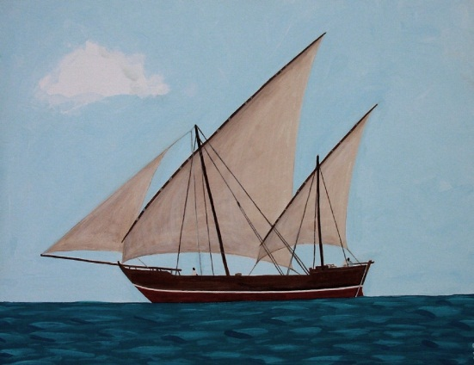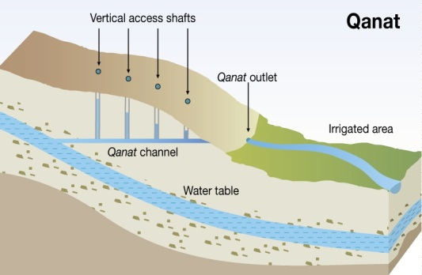

PERIOD 3: 600 to 1450

Key Concept 3.1. Expansion and Intensification of Communication and Exchange Networks

I. Trade: Improved transportation technologies and commercial practices led to an increased volume of trade, and expanded the geographical range of existing and newly active trade networks.
A. Existing trade routes flourished and led to powerful new trading cities.
Routes: Silk Roads, Indian Ocean, Med Sea, Indian Ocean

Cities: Novgorod, Timbuktu, Swahili city-states, Hangzhou, Calicut, Baghdad, Melaka, Venice,

B. New trade routes centering on Mesoamerica and the Andes developed.
C. The growth of interregional trade in luxury goods was encouraged by significant innovations in technologies, including more sophisticated caravan organization, use of the compass, astrolabe, and larger ship designs in sea travel; and new forms of credit and monetization.

Luxury Goods: Silk/cotton textiles, Porcelain, Spices, Precious metals & gems, Slaves, Exotic animals

Caravan organization: Caravanserai (roadside inns), Camel saddles
Forms of credit: Bills of exchange, Credit, Checks, Banking houses

D. Commercial growth was also facilitated by state practices, trading organizations, and infrastructure
Ex: The Grand Canal in China, minting of coins and paper money; Hanseatic League
E. The expansion of empires facilitated Trans-Eurasian trade and communication as new peoples were drawn into their conquerors’ economies and trade networks
Ex: China, the Byzantine Empire, the Caliphates, the Mongols

II. Migration: The movement of peoples caused environmental and linguistic effects.
A. The expansion of trade routes depended on environmental knowledge and technological adaptations.
Ex: Vikings longships; Arabs/Berbers used camels in Sahara; Central Asian herders used horses
B. Some migrations had a significant environmental impact.
Bantu: facilitated transmission of iron technologies and agricultural techniques in Sub-Saharan Africa
Polynesian: maritime, cultivated transplanted foods & domesticated animals as moved to new islands
C. Some migrations and trade led to diffusion of language: Bantu (including Swahili), Turkish, Arabic
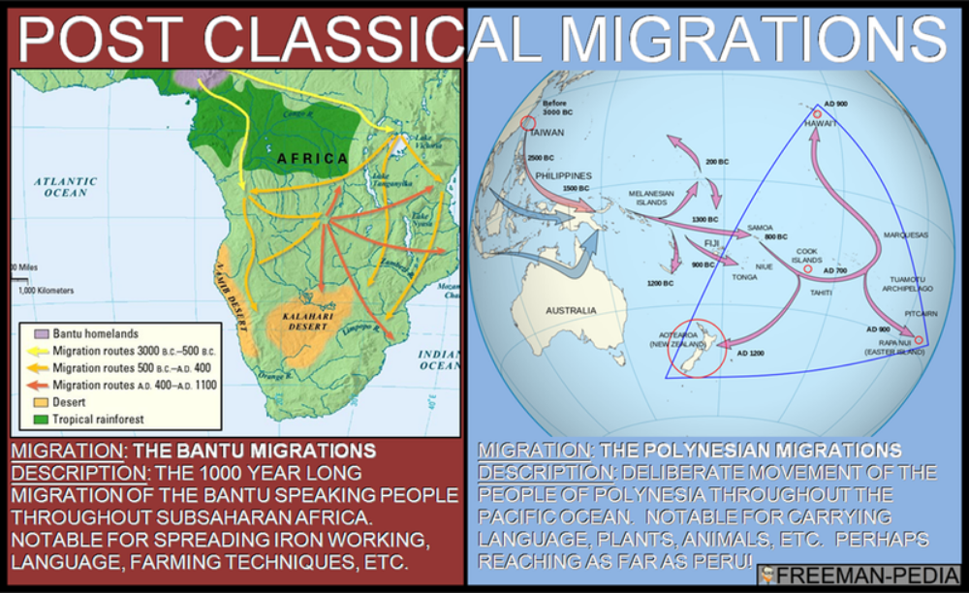
III. Diffusion: Cross-cultural exchanges were fostered by existing and new trade routes.
A. Islam: Islam, based on the revelations of the prophet Muhammad, developed in the Arabian Peninsula. The beliefs and practices of Islam reflected interactions among Jews, Christians, and Zoroastrians with the local Arabian peoples. Muslim rule expanded to Afro-Eurasia due to military expansion, and later activities of merchants and missionaries.
B. Merchants set up diasporic communities in key places where they introduced their own cultural traditions into the indigenous culture. Ex: Muslim merchant communities in the Indian Ocean region, Chinese merchant communities in SE Asia, Jewish communities in the Med, IOT, SR.
C. The writings of certain interregional travelers illustrate both the extent and the limitations of intercultural knowledge and understanding. Ex: Ibn Battuta, Marco Polo, Xuanzang

D. Increased cross-cultural interactions resulted in cultural diffusion.
Ex: Neoconfucianism & Buddhism in East Asia, Hinduism & Buddhism in SE Asia, Islam in S-S Africa
& SE Asia, Toltec/Mexica & Inca traditions in Mesoamerica & Andes
E. Increased cross-cultural interactions resulted in the diffusion of scientific and technological traditions.
Ex: Influence of Greek & Indian mathematics on Muslim scholars; the return of Greek science and
philosophy to Western Europe via Muslim al-Andalus in Iberia; Spread of printing & gunpowder
technology from East Asia Islamic empires & W. Europe

IV. Continued diffusion of crops and pathogens throughout the Eastern Hemisphere along the trade routes.
A. New foods and agricultural techniques were adopted in populated areas:
Champa rice from Vietnam to China in East Asia; Spread of cotton, sugar, and citrus throughout Dar al-Islam and the Mediterranean basin; Bananas in Africa
B. The spread of epidemic diseases, including the Black Death, followed trade routes.

Key Concept 3.2. Continuity and Innovation of State Forms and Their Interactions
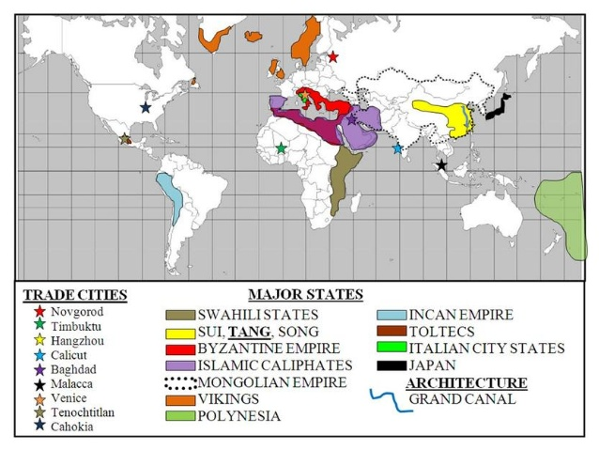
I. Empires: Empires collapsed and were reconstituted; in some regions new state forms emerged.
A. Following the collapse of empires, most reconstituted governments, including the Byzantine Empire and the Chinese dynasties — Sui, Tang, and Song — combined traditional sources of power and legitimacy (patriarchy, religion, land-owning elites) with innovations better suited to the current circumstances (new taxation, tribute systems, religions).
B. New forms of governance:
- Islamic states (Abbasids, Muslim Iberia, Delhi sultanates)
- Mongol Khanates
- City-states (Italian, SE Asian, American)
- Decentralized government (feudalism) in Europe and Japan.
C. Some states synthesized local and borrowed traditions.
Ex: Persian traditions Islamic states, Chinese Japan; Byzantine Russia
D. In the Americas, as in Afro-Eurasia, state systems expanded in scope and reach: Networks of city-states flourished in the Maya region and, at the end of this period, imperial systems were created by the Mexica (“Aztecs”) and Inca.

II. Diffusion: Interregional contacts and conflicts between states and empires encouraged significant technological and cultural transfers.
Ex: Between Tang China and the Abbasids, across the Mongol empire, during the Crusades

Key Concept 3.3. Increased Economic Productive Capacity and Its Consequences
I. Innovations stimulated agricultural and industrial production in many regions.
A. Agricultural production increased significantly due to technological innovations. Ex: Champa rice varieties, Chinampa field systems (Aztec), Waru waru techniques (Inca), terracing, horse collar
B. In response to increasing demand in Afro-Eurasia for foreign luxury goods, crops were transported from their indigenous homelands to equivalent climates in other regions.
C. Chinese, Persian, and Indian artisans and merchants expanded their production of textiles and porcelains for export; industrial production of iron and steel expanded in China.

II. Cities: The fate of cities varied greatly, with periods of significant decline, and with periods of increased urbanization buoyed by rising productivity and expanding trade networks.
A. Multiple factors contributed to the declines of urban areas in this period, such as invasions, disease, agricultural decline.
B. Multiple factors contributed to urban revival. Examples: End of invasions, safer transport, rise of trade, warmer temps 800 to 1300, increased productivity and rising pops, labor supply
C. While cities in general continued to play the roles they had played in the past as governmental, religious, and commercial centers, many older cities declined while numerous new cities emerged.

III. Social Change and Continuity: Despite significant continuities in social structures and in methods of production, there were also important changes in labor management and in the effect of religious conversion on gender relations and family life.
A. As in the previous period, there were many forms of labor organization. Ex: free peasant agriculture, nomadic pastoralism, craft production/guild organization, coerced/unfree labor, govt imposed labor taxes (mita-Inca), military
B. As in previous eras, social structures were shaped largely by class and caste hierarchies. Patriarchy persisted; however, women had more power/influence among the Mongols and in West Africa, Japan, and SE Asia.
C. New forms of coerced labor appeared, including serfdom in Europe and Japan and the elaboration of the mit’a in the Inca Empire. Free peasants resisted attempts to raise dues and taxes by staging revolts in Byzantine and China. Demand for slaves (military/domestic) increased, particularly in central Eurasia, parts of Africa, and the eastern Mediterranean.
D. Diffusion of Buddhism, Christianity, Islam, and Neoconfucianism big changes in gender relations & family structure.
PERIOD 4: 1450 to 1750
Key Concept 4.1. Globalizing Networks of Communication and Exchange, 1450-1750

I. Continuity: This era witnessed the intensification of all existing regional trade networks, resulting in both continued prosperity and economic disruption to merchants & governments in the Indian Ocean, Mediterranean, Sahara, and overland Eurasia.

II. Technology: European technological developments in cartography & navigation built on previous knowledge from classical, Islamic, & Asian worlds, including improved understanding of global wind and currents patterns.
Examples: New tools- Astrolabe, revised map; Innovations in ship designs: caravels

III. Exploration: Remarkable new transoceanic maritime reconnaissance occurred in this period.
A. Official Chinese maritime activity expanded into the Indian Ocean with the voyages led by Ming Admiral Zheng He to enhance China’s prestige.
B. A Portuguese school for navigation was founded by Prince Henry, leading to an increase in travel and trade with West Africa, and later the development of a global trading-post empire.
C. Spanish sponsorship of Columbus and later explorers across the Atlantic and Pacific increased European interest in trade and travel.
D. Northern Atlantic crossings for fishing & settlements continued & spurred European searches for a northwest passage to Asia.
E. In Oceania and Polynesia, established exchange and communication networks were not dramatically affected because of infrequent European reconnaissance in the Pacific Ocean.

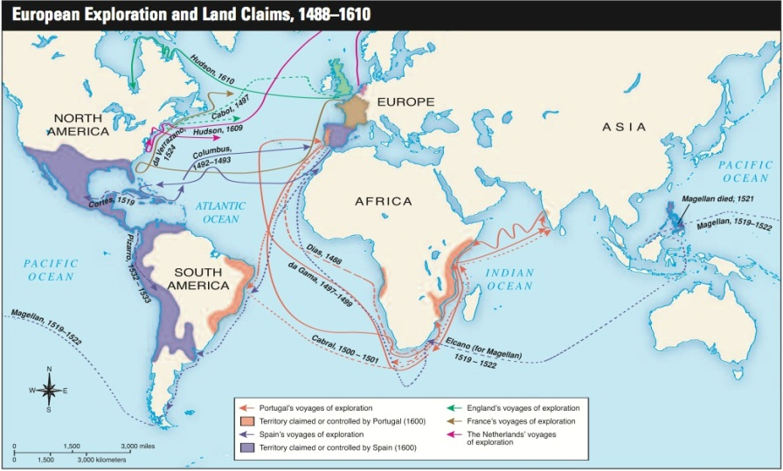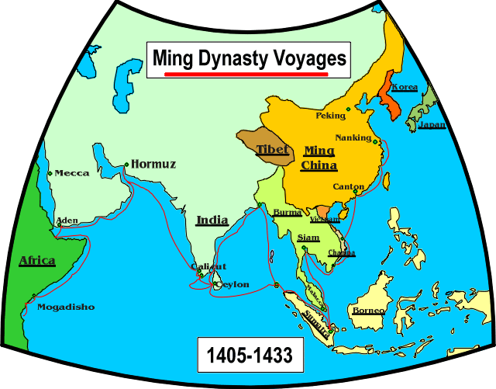

IV. Commercial Revolution: The new global circulation of goods was facilitated by royal chartered European monopoly companies that took silver from Spanish colonies in the Americas to purchase Asian goods for the Atlantic markets, but regional markets continued using established practices & new shipping services developed by European merchants.
A. European merchants’ in Indian Ocean mainly transported goods from one Asian country to another Asian market.
B. Commercialization and the creation of a global economy linked to new global circulation of silver from the Americas.
C. Influenced by mercantilism, joint-stock companies were new methods used by European rulers to control their domestic and colonial economies and by European merchants to compete against one another in global trade.
D. The Atlantic system involved the movement of goods, wealth, and free and unfree laborers, and the mixing of African, American, and European cultures and peoples. (Triangular Trade)

V. Columbian Exchange: The new connections between the Eastern and Western hemispheres resulted in the Columbian Exchange.
A. European colonization of the Americas led to the spread of diseases (smallpox, measles, influenza) endemic in the Eastern Hem. to Amerindian populations; also unintentional transfer of mosquitoes, rats.
B. American foods (potatoes, maize, manioc) became staple crops in various parts of Afro-Eurasia.
Cash crops (sugar, tobacco) were grown on plantations w/ slave labor and exported to Europe.
C. Afro-Eurasian fruit trees, grains, sugar, and animals (horses, pigs, cattle) were brought by Europeans
D. Populations in Afro-Eurasia benefited nutritionally from the increased diversity of American food crops.
E. European colonization and the introduction of European agriculture and settlements practices in the Americas often affected the physical environment through deforestation and soil depletion.

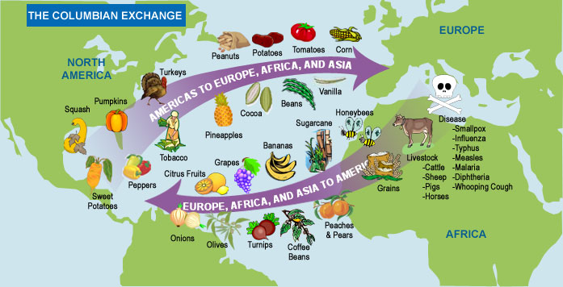

VI. Religious Diffusion and Division: Increased interactions between newly connected hemispheres expanded the spread and reform of existing religions and created syncretic belief systems and practices.
A. As Islam spread to new settings in Afro-Eurasia, believers adapted it to local cultural practices. The split between the Sunni and Shi’a traditions intensified, and Sufi practices became more widespread.
B. Christianity continued to spread and was diversified by diffusion to Americas and Reformation.
C. Buddhism spread within Asia.
D. Syncretic and new forms of religion developed. (Vodun in Caribbean, Cults of saints in Latin America, Sikhism in South Asia

VII. Art: As merchants’ profits increased and governments collected more taxes, funding for the visual and performing arts, even for popular audiences, increased.
A. Innovations: Renaissance art in Europe, mini-paintings in Middle East and South Asia, wood-block prints in Japan, Mesoamerican codices
B. Literacy expanded popular authors, literary forms, and works of literature in Afro-Eurasia. Shakespeare, Cervantes (Don Quixote), Sundiata, Journey to the West, Kabuki theatre

Key Concept 4.2. New Forms of Social Organization and Modes of Production

I. Labor Systems: Traditional peasant agriculture increased and changed, plantations expanded, and demand for labor increased.
A. Peasant labor intensified (frontier settlements in Russian Siberia, textiles in India, silk in China)
B. Slavery in Africa continued both traditional household slavery and export to Med Sea & Indian Ocean.
C. The growth of the plantation economy increased the demand for slaves in the Americas.
D. Forced labor in Colonial America included chattel slavery, Indentured servitude, Encomienda; Spanish use of the Inca mit’a (unpaid labor obligations to the state).
II. Social Structures: As new social and political elites changed, they also restructured new ethnic, racial, and gender hierarchies.
A. Both imperial conquests & global economic opportunities formation of new political and economic elites. Ex: Manchus in China, Creole elites in Spanish America, European gentry, Urban traders
B. The power of existing political and economic elites fluctuated as they confronted new challenges to their ability to affect the policies of the increasingly powerful monarchs and leaders.
Ex: zamindars in Mughal, nobility in Europe, daimyo in Japan
C. Some notable gender and family restructuring occurred, including the demographic changes in Africa that resulted from the slave trades. Ex: dependence of European men on SE Asian women for trade; smaller size of European families
D. The massive demographic changes in Americas new ethnic and racial classifications. Mestizo (mixed European and Native American), mulatto (mixed Euro & African), creole (American-born whites)

Key Concept 4.3. State Consolidation and Imperial Expansion

I. State Consolidation: Rulers used a variety of methods to legitimize and consolidate their power.
A. Arts to display power: Monumental architecture, Urban design, Courtly literature, The visual arts

B. Rulers continued to use religious ideas to legitimize their rule. Safavid use of Shiism, Aztec human sacrifice, Songhay promotion of Islam, Chinese emperors’ public performance of Confucian rituals

C. States treated different ethnic and religious groups in ways that utilized their economic contributions while limiting ability to challenge state authority. Ex: Ottoman use of non-Muslims, Manchu policies toward Chinese, Spanish “Republica de Indios”
D. Recruitment and use of bureaucratic elites, as well as the development of military professionals, became more common among rulers who wanted to maintain centralized control over their populations and resources. Ex: Ottoman devshirme, Chinese exam system
E. Rulers used tribute collection and tax farming to generate revenue for territorial expansion.

II. Imperial expansion relied on the increased use of gunpowder, cannons, and armed trade to establish large empires.
A. Europeans established new trading-post empires in Africa and Asia (increased profits for rulers and merchants), but these empires also affected the power of the states in interior West and Central Africa.
B. Land empires expanded dramatically in size: Manchus (Qing), Mughals, Ottomans, Russians
C. European states established new maritime empires in the Americas:
Portuguese, Spanish, Dutch, French, British

III. Challenges to state consolidation and expansion.
A. Competition over trade routes: Omani-European rivalry in the Indian Ocean, Piracy in the Caribbean.
B. State rivalries: Thirty Years War (Catholic v. Protestant), Ottoman-Safavid conflict (Shia v. Sunni).
C. Local resistance: food riots, samurai revolts, peasant uprisings
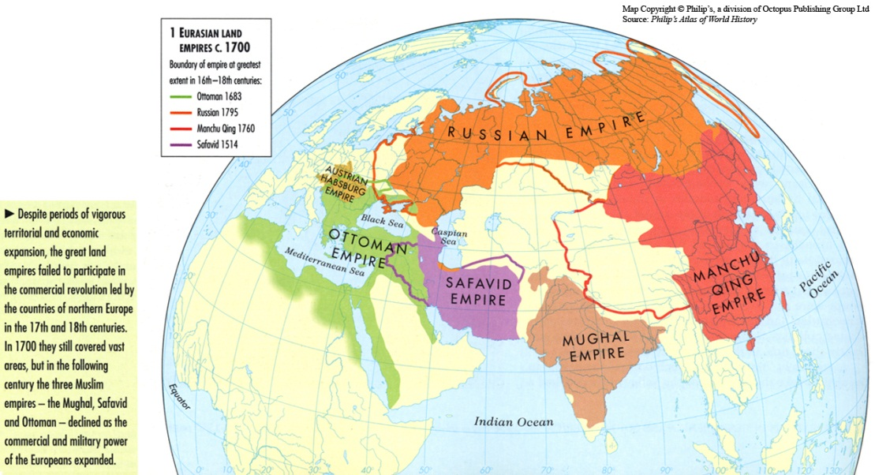
PERIOD 5: 1750 to 1900
Key Concept 5.1. Industrialization and Global Capitalism

I. Industrialization fundamentally changed how goods were produced.
A. A variety of factors led to the rise of industrial production.: Europe’s location on the Atlantic Ocean; the geographical distribution of coal, iron and timber; European demographic changes; Urbanization; Improved agricultural productivity; Legal protection of private property; An abundance of rivers and canals; Access to foreign resources; accumulation of capital

B. The development of machines, including steam engines and the internal combustion engine, made it possible to exploit vast new resources of energy stored in fossil fuels, specifically coal and oil. The “fossil fuels” revolution greatly increased the energy available to human societies.
C. The development of the factory system concentrated labor in a single location and led to an increasing degree of specialization of labor.
D. As the new methods of industrial production became more common in parts of northwestern Europe, they spread to other parts of Europe and the United States, Russia, and Japan.
E. The “second industrial revolution” led to new steel production, chemicals, electricity and precision machinery (1850-1900).

II. Global Trade: New global trade patterns further integrated the global economy as industrialists sought raw materials & new markets.
A. The need for raw materials for the factories and increased food supplies for the growing population in urban centers led to the growth of export economies around the world that specialized in mass producing single natural resources; then using profits to purchase finished goods.
Ex: Cotton, Rubber, Palm oil, Sugar, Wheat, Meat, Guano, Metals and minerals

B. The rapid development of industrial production contributed to the decline of economically productive, agriculturally based economies. Example: Textile production in India
C. The rapid increases in productivity caused by industrial production encouraged industrialized states to seek out new consumer markets for their finished goods.
Ex: British & French attempts to “open up” China in 19th century (Opium Wars)
D. The need for precious metals for industrial production + global demand for gold, silver and diamonds as forms of wealth, led to the development of extensive mining centers.
Ex: Copper mines in Mexico; Gold/diamond mines in South Africa

III. Finance: Financiers developed and expanded financial institutions to facilitate investment.
A. The ideological inspiration for economic changes lies in the development of capitalism and classical liberalism associated with Adam Smith and John Stuart Mill.
B. Financial instruments expanded. Ex: Stock markets, Insurance, Gold standard, Limited liability corporations

C. The global nature of trade and production contributed to the proliferation of large-scale transnational businesses. Ex: The United Fruit Company

IV. There were major developments in transportation & communication.
Required examples: Railroads, Steamships, Telegraphs, Canals

V. Global Capitalism: The development and spread of global capitalism led to a variety of responses.
A. In industrialized states, many workers organized themselves to improve working conditions, limit hours, and gain higher wages, while others opposed capitalist exploitation of workers by promoting alternative visions of society. Ex: Utopian socialism, Marxism, Anarchism
B. In Qing China and the Ottoman Empire, some members of the government resisted economic change and attempted to maintain preindustrial forms of economic production.

C. In a small number of states, governments promoted their own state-sponsored visions of industrialization. Examples:
• The economic reforms of Meiji Japan
• The development of factories and railroads in Tsarist Russia
• China’s Self-Strengthening Movement
• Muhammad Ali’s dev. of a cotton textile industry in Egypt
Compare: China’s loss of sovereignty to western powers v. Japan’s successful modernization.
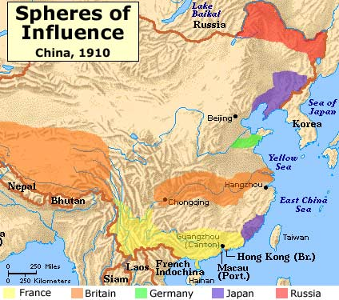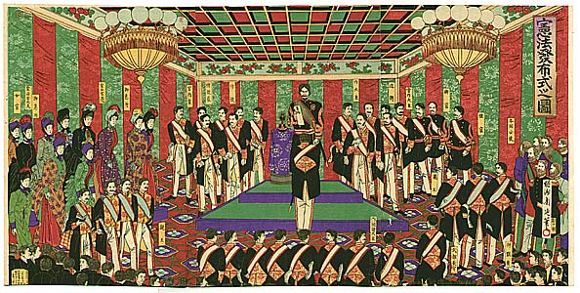

D. In response to criticisms of industrial global capitalism, some governments mitigated negative effects of capitalism by promoting reforms. Examples: state pensions and public health in Germany, expanded suffrage in Britain, public education many states

VI. Social Change: The ways in which people organized themselves into societies also underwent significant transformations.
A. New social classes, including the middle class and the industrial working class, developed.
B. Family dynamics, gender roles, and demographics changed in response to industrialization. Rapid urbanization that accompanied global capitalism often led to unsanitary conditions, as well as to new forms of community.

Key Concept 5.2. Imperialism and Nation-State Formation

I. Industrializing powers established transoceanic empires.
A. States with existing colonies strengthened their control over those colonies
Examples: British in India, Dutch in Indonesia

B. European states, as well as the Americans and the Japanese, established empires throughout Asia and the Pacific, while Spanish and Portuguese influence declined.
Examples: British, Dutch, French, German, Russian
C. Many European states used both warfare and diplomacy to establish empires in Africa.
Examples: British in West Africa, Belgium in Congo

D. In some parts of their empires, Europeans established settler colonies.
Examples: British in South Africa, Australia, NZ; French Algeria
E. In other parts of the world, industrialized states practiced economic imperialism.
Ex: British + French in China through the Opium Wars; British + U.S. investment in Latin America

II. Imperialism influenced state formation and contraction around the world.
A. The expansion of U.S. & European influence over Tokugawa Japan emergence of Meiji Japan.
B. The USA & Russia emulated European imperialism by expanding land borders/ conquering territories.
C. Anti-imperial resistance contraction of the Ottoman Empire: Est. of independent states in Balkans; Semi-independence in Egypt; French and Italian colonies in North Africa; Later British influence in Egypt
D. New states developed on the edges of existing empires. Ex: Cherokee Nation, Siam, Hawai’i, Zulu
E. The development and spread of nationalism: German nation, Filipino nationalism, Liberian nationalism

III. Racism: New racial ideologies, especially Social Darwinism, facilitated and justified imperialism.
Key Concept 5.3. Nationalism, Revolution, and Reform

I. The Enlightenment: The rise and diffusion of Enlightenment thought that questioned established traditions in all areas of life often preceded the revolutions and rebellions against existing governments.
A. Thinkers applied new ways of understanding the natural world to human relationships, encouraging observation and inference in all spheres of life. Ex: Voltaire, Rousseau

B. Intellectuals critiqued the role that religion played in public life, stressed importance of reason as opposed to revelation.
C. Enlightenment thinkers developed new ideas about the individual, natural rights, and the social contract. Ex: Locke, Montesquieu

D. The ideas of Enlightenment thinkers influenced resistance to existing political authority, as reflected in revolutionary documents. Examples: Declaration of Independence, French Declaration of the Rights of Man and Citizen, Bolivar’s Jamaica Letter
E. These ideas influenced many people to challenge existing notions of social relations, which led to the expansion of rights as seen in expanded suffrage, the abolition of slavery and the end of serfdom, as their ideas were implemented.
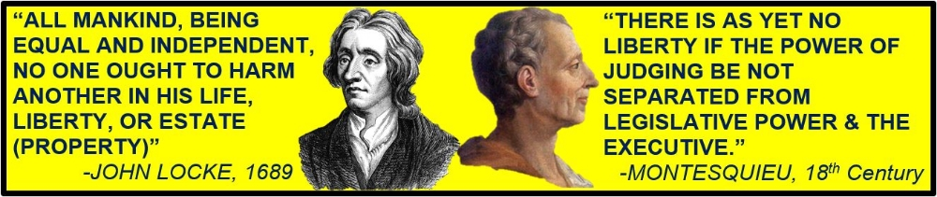

II. Nationalism: Beginning in the eighteenth century, peoples around the world developed a new sense of commonality based on language, religion, social customs and territory. These newly imagined national communities linked this identity with the borders of the state, while governments used this idea to unite diverse populations.

III. Revolutions: Increasing discontent with imperial rule propelled reformist and revolutionary movements.
A. Subjects challenged imperial governments. Example: The challenge of the Marathas to Mughals
B. American colonial subjects led a series of rebellions, which facilitated the emergence of independent states in the United States, Haiti, and mainland Latin America. French subjects rebelled against their monarchy.

C. Slave resistance challenged existing authorities in the Americas with establishment of Maroon societies (communities of escaped slaves).
D. Increasing questions about political authority and growing nationalism contributed to anticolonial movements. Examples: The Indian Revolt of 1857 (Sepoy Mutiny); The Boxer Rebellion in China
E. Some of the rebellions were influenced by religious ideas and millenarianism.
Examples: Taiping Rebellion, Ghost Dance, Xhosa Cattle Killing Movement
F. Responses to increasingly frequent rebellions led to reforms in imperial policies.
Examples: Tanzimat in the Ottoman Empire, Self-Strengthening in China both failed

IV. New Ideologies: The global spread of European political and social thought and the increasing number of rebellions stimulated new transnational ideologies and solidarities.
A. Discontent w/ monarchist & imperial rule led to the development of political ideologies, including liberalism, socialism, and communism.
B. Demands for women’s suffrage and an emergent feminism challenged political and gender hierarchies. Examples: Mary W.’s A Vindication of the Rights of Woman; Olympe de Gouges’s “Declaration of the Rights of Women”; Seneca Falls Conference in 1848

Key Concept 5.4. Global Migration

I. Migration Intro: Migration influenced by changes in demography in industrialized & unindustrialized societies challenges.
A. Changes in food production & improved medical conditions significant global rise in population.
B. Migrants increasingly relocated to cities, resulting in significant global urbanization of the 19th century.

II. Causes: Migrants relocated for a variety of reasons.
A. Many individuals chose freely to relocate in search of work.
Ex: Manual laborers, professionals
B. The new global capitalist economy continued to rely on coerced & semicoerced labor migration, including convict labor, slavery, and Chinese and Indian indentured servitude
C. While many migrants permanently relocated, a significant number of temporary and seasonal migrants returned to their home societies.
Ex: Japanese agricultural workers in the Pacific, Lebanese merchants in Americas, Italians in Argentina

III. Responses to Migration: The large-scale nature of migration, especially in the 1800s, produced a variety of effects and reactions to the increasingly diverse societies.
A. Due to the physical nature of the labor in demand, migrants tended to be male, leaving women to take on new roles in the home society that had been formerly occupied by men.
B. Migrants often created ethnic enclaves in different parts of the world which helped transplant their culture into new environments and facilitated the development of migrant support networks.
Ex: Chinese in SE Asia, Caribbean, S. America, N. America
Indians in East and southern Africa, the Caribbean, and SE Asia
C. Receiving societies did not always embrace immigrants, as seen in the various degrees of ethnic and racial prejudice and the ways states attempted to regulate the increased flow of people across their borders.
Ex: The Chinese Exclusion Acts; the White Australia Policy
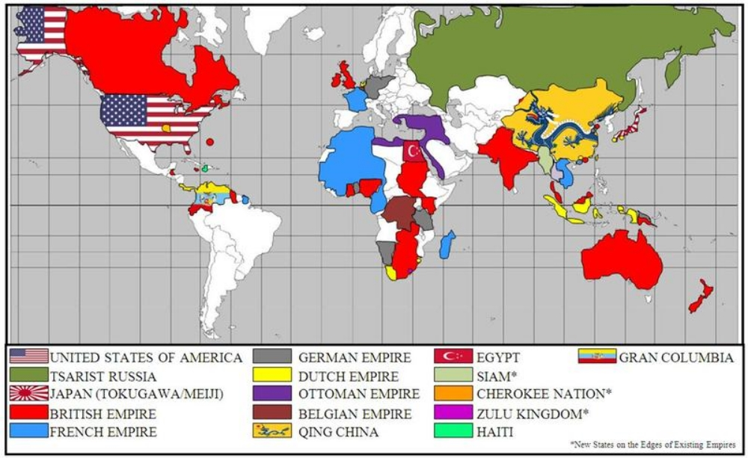

PERIOD 6: 1900 to Present

Key Concept 6.1 Science and the Environment

I. Researchers made rapid advances in science, assisted by the development of new technology.
A. New modes of communication & transportation virtually eliminated problem of geographic distance.
B. New scientific paradigms transformed human understanding of the world. Ex: Theory of relativity, quantum mechanics, the Big Bang theory, psychology
C. The Green Revolution produced food for earth’s growing population as it spread chemically & genetically enhanced forms of agriculture.
D. Medical innovations increased ability of humans to survive. Polio vaccine, antibiotics, artificial heart
E. New energy technologies raised productivity and increased the production of material goods. Ex: oil, nuclear power.

II. Humans fundamentally changed their relationship with the environment.
A. Humans exploited and competed over the earth’s finite resources more intensely than ever before.
B. Global warming was a major consequence of the release of greenhouse gases & other pollutants into the atmosphere.
C. Pollution threatened the world’s supply of water and clean air. Deforestation and desertification were continued consequences of the human impact on the environment. Rates of extinction of other species accelerated sharply.

III. Disease, scientific innovations and conflict led to demographic shifts.
A. Diseases associated with poverty (malaria, tuberculosis, cholera) persisted, while other diseases (1919 influenza pandemic, ebola, HIV/AIDS) emerged as new epidemics and threats to human survival. In addition, changing lifestyles and increased longevity led to higher incidence of certain diseases (diabetes, heart disease, Alzheimer’s disease).
B. More effective forms of birth control gave women greater control over fertility & transformed sexual practices.
C. Improved military technology (tanks, airplanes or the atomic bomb) and new tactics (trench warfare, firebombing) led to increased levels of wartime casualties (Nanjing, Dresden, Hiroshima).

Key Concept 6.2 Global Conflicts and Their Consequences

I. End of European empire: Europe dominated the global political order at the beginning of the 20th century, but both land-based and transoceanic empires gave way to new forms of transregional political organization by the century’s end.
A. Older land-based empires (Ottoman, Russian, Qing) collapsed due to a combination of internal and external factors. Ex: economic hardship, political/social discontent, technological stagnation, defeat.
B. Some colonies negotiated their independence. Ex: India & Gold Coast from the British Empire.
C. Some colonies achieved independence through armed struggle. Ex: Algeria and Vietnam from the French empire; Angola from the Portuguese empire.

II. Nationalist Ideology: Emerging ideologies of anti-imperialism contributed to the dissolution of empires.
A. Nationalist leaders in Asia and Africa challenged imperial rule.
Ex: Mohandas Gandhi in India, Ho Chi Minh in Vietnam, Kwame Nkrumah in Ghana.
B. Regional, religious and ethnic movements challenged both colonial rule and inherited imperial boundaries.
Ex: Muhammad Ali Jinnah in Pakistan, the Quebecois separatist movement in Canada or the Biafra secessionist movement in Nigeria.
C. Transnational movements sought to unite people across national boundaries. Ex: communism, Pan-Arabism or Pan- Africanism.
D. Within states in Africa, Asia and Latin America, movements promoted communism and socialism as a way to redistribute land and resources.
III. Political changes were accompanied by major demographic and social consequences.
A. The redrawing of old colonial boundaries led to population resettlements. Ex: India/Pakistan partition, the Zionist Jewish settlement of Palestine or the division of the Middle East into mandatory states.
B. The migration of former colonial subjects to imperial metropoles maintained cultural and economic ties between the colony and the metropole even after the dissolution of empires. Ex: South Asians to Britain, Algerians to France, Filipinos to USA.
C. The proliferation of conflicts led to genocide (Armenia, the Holocaust, Cambodia, Rwanda) and the displacement of peoples resulting in refugee populations (Palestinians, Darfurians).

IV. Global war: Military conflicts occurred on an unprecedented global scale.
A. World War I and World War II were the first “total wars.” Governments used ideologies, including fascism, nationalism and communism, to mobilize all of their state’s resources, including peoples, both in the home countries and the colonies or former colonies for the purpose of waging war. Ex: Gurkha soldiers in India, ANZAC troops in Australia. Governments also used a variety of strategies, including political speeches, art, media and intensified forms of nationalism, to mobilize these populations.
B. The varied sources of global conflict from 1900 to 1950 included: imperialist expansion by European powers and Japan, competition for resources, ethnic conflict, great power rivalries between Great Britain and Germany, nationalist ideologies, and the economic crisis engendered by the Great Depression.
C. The global balance of economic and political power shifted after the end of World War II and rapidly evolved into the Cold War. The United States and the Soviet Union emerged as superpowers, which led to ideological struggles between capitalism and communism throughout the globe.
D. The Cold War produced new military alliances, including NATO and the Warsaw Pact, and promoted proxy wars in Latin America, Africa and Asia.
E. The dissolution of the Soviet Union effectively ended the Cold War.

V. Violence: Although conflict dominated much of the 20th century, many individuals and groups opposed this trend. Some individuals and groups, however, intensified the conflicts.
A. Groups and individuals challenged the many wars of the century. Ex: Picasso in his Guernica, the antinuclear movement during the Cold War, Thich Quang Duc by self-immolation. Some promoted the practice of nonviolence as a way to bring about political change. Ex: Tolstoy, Gandhi, Martin Luther King.
B. Groups and individuals opposed and promoted alternatives to the existing economic, political and social orders. Ex: The Non-Aligned Movement, which presented an alternative political bloc to the Cold War; the Tiananmen Square protesters for democracy in China; Anti-Apartheid Movement; or participants in the global uprisings of 1968.
C. Militaries and militarized states often responded to the proliferation of conflicts in ways that further intensified conflict. Ex: the promotion of military dictatorship in Chile, Spain and Uganda; the United States’ promotion of a New World Order after the Cold War; the buildup of the “military-industrial complex” and arms trading.
D. More movements used terrorism to achieve political aims. Ex: the IRA, Al-Qaeda
E. Global conflicts had a profound influence on popular culture. Ex: Dada, James Bond, Socialist Realism, video games.

Anti-War Images: Picasso’s Guernica, self-immolation
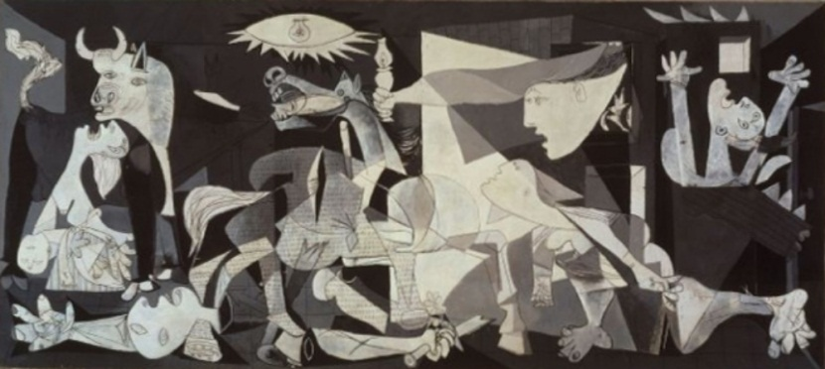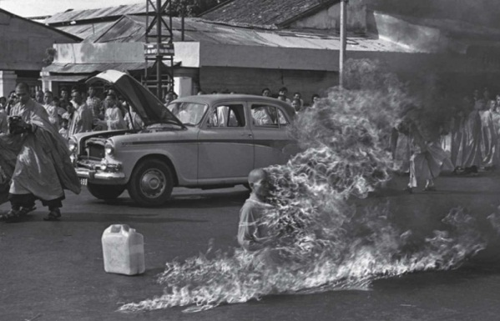
Key Concept 6.3 New Conceptualizations of Global Economy, Society and Culture

I. States, communities and individuals became increasingly interdependent, a process facilitated by the growth of institutions of global governance.
A. New international organizations formed to maintain world peace and to facilitate international cooperation.
Ex: The League of Nations, the United Nations.
B. New economic institutions sought to spread the principles and practices associated with free market economics throughout the world. Ex: the IMF, World Bank, WTO.
C. Humanitarian organizations developed to respond to humanitarian crises throughout the world.
Ex: UNICEF, the Red Cross, Amnesty International, Doctors Without Borders, WHO.
D. Regional trade agreements created regional trading blocs designed to promote the movement of capital and goods across national borders. Ex: European Union, NAFTA, ASEAN, Mercosur.
E. Multinational corporations began to challenge state authority and autonomy.
Ex: Royal Dutch Shell, Coca-Cola, Sony.
F. Movements throughout the world protested the inequality of environmental and economic consequences of global integration.

II. People conceptualized society and culture in new ways; some challenged old assumptions about race, class, gender and religion, often using new technologies to spread reconfigured traditions.
A. The notion of human rights gained traction throughout the world. Ex: The U.N. Universal Declaration of Human Rights, women’s rights, the end of the White Australia Policy.
B. Increased interactions among diverse peoples sometimes led to the formation of new cultural identities (such as negritude) and exclusionary reactions (such as xenophobia, race riots or citizenship restrictions).
C. Believers developed new forms of spirituality (such as New Age Religions, Hare Krishna or Falun Gong) and chose to emphasize particular aspects of practice within existing faiths and apply them to political issues (such as fundamentalist movements or Liberation Theology).

III. Popular and consumer culture became global.
A. Sports were more widely practiced and reflected national and social aspirations. Ex: World Cup Soccer, the Olympics, cricket.
B. Changes in communication and transportation technology enabled the widespread diffusion of music and film. Ex: reggae, Bollywood.

Chinese History Overview

Dynasty | Years | Characteristics/Changes
Shang | 1600-1046 BCE | Warrior-kings; human sacrifices to ancestors; Writing began (oracle bones)  Developed bronze, glazed pottery, silk industries; Huang He agriculture
Zhou | 1045-256 BCE | Invaded China from NW; claimed Mandate of Heaven  Set up a loose central government; Feudal power held by strong nobles  Decline led to Warring States Period- Confucius, Laozi
Qin | 221-206 BCE | Military dictatorship centralized China; Emperor Qin Shi Huangdi (Legalism)  Destroyed nobles’ feudal power; System of taxation, weights and measures, standard writing; Great Wall (1500 miles), Terra Cotta warriors
Han | 206 BCE- 220 CE | Conquerors; expanded to central Asia, Indochina, Korea  Traded with Rome along Silk Roads; Wudi begins civil service exam system based on Confucius; First paper made  Buddhism enters China in 200s from India (Silk Road); high point 300-800
Sui | 589-618 | Reunified China; Canal system; State support of Buddhism (Wendi)
Tang | 618-906 | “Golden Age” of arts and literature; Education and government reforms  Extended boundaries of empire; Alliance and peace treaties with neighbors; tribute system; High point of influence on Japan; capital Hangzhou  Later Tang- state action against Buddhism; emergence of Neo-Confucianism
Song | 960-1279 | “Economic revolution”: Increased urbanization, cosmopolitan  Powerful only in southern China; nomads ruled North  Inventions: gunpowder, compass, printing  Foot binding, especially elite women; Neo-Confucianism
Yuan | 1259-1368 | Mongol rule; Northern China conquered by Genghis Khan  Song conquered and ruled by Kublai Khan (Genghis’ grandson)  Visited by Marco Polo trade with Europe began
Ming | 1368-1644 | Period of recovery from Mongol rule; capital moved to Beijing  Sponsorship of Zheng He’s voyages (1405-1433) ended, evidence destroyed  Growing isolation from world trade, construction of Great Wall  Trade with Europeans along Indian Ocean; arrival of Jesuit missionaries
Qing | 1644-1911 | Ming conquered by Manchus from NW China  Period of expansion into Central Asia, Tibet largest land borders  Policies of discrimination against Han Chinese (dual appointments)  1800s disasters: Opium Wars, Taiping Rebellion, Boxer Rebellion (fails)
Warlord/ Republic | 1911-1949 | 1911 Qing overthrown by nationalists in revolution; leader- Sun Yat-Sen  Nationalists (Chiang Kai-Shek) v. Communists (Mao Zedong)  Invaded by Japan in 1937 during WWII  1946: Civil War resumes
Communist China | 1949- Present | Mao declares victory; proclaims People’s Republic of China  Nationalists forced to flee to Taiwan (island)  Mao’s policies: Great Leap Forward (similar to Stalin’s Five Year Plans), Cultural Revolution to go after communism’s enemies  After Mao’s death in 1976, Deng Xiaoping emerges as leader – pursues policy of economic liberalization, leading to rapid economic growth  1989 Tiananmen Square Massacre – students protesting for democracy slaughtered by military
Song: Shang, Zhou, Qin, Han (X2), Sui, Tang, Song (X2), Yuan, Ming, Qing, Republic (X2), Mao Zedong (X2)
Political, Economic, and Social Systems (The “-isms”)
Feudalism | Feudalism usually refers to the political, social, and economic system of medieval Europe derived from the holding of land in exchange for labor or service. Feudalism is politically decentralized. Economically, production occurs on the manor. Socially, it creates three classes: the nobility, the clergy, and the peasantry. Feudalism also developed in Japan. | 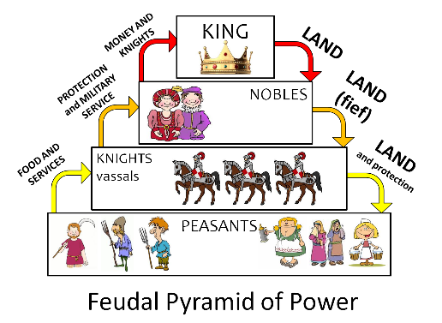
Nationalism | Nationalism involves identifying with one's nation, which can be defined by a common ethnic, cultural, or religious identity, or common values and history. The adoption of national identity has commonly been the result of dissatisfaction with foreign rule or disunity and has often involved revolutions. An important belief of nationalism is that the nation deserves a discrete territory and government (state) controlled by the people. National flags, anthems are considered important symbols of the nation. | 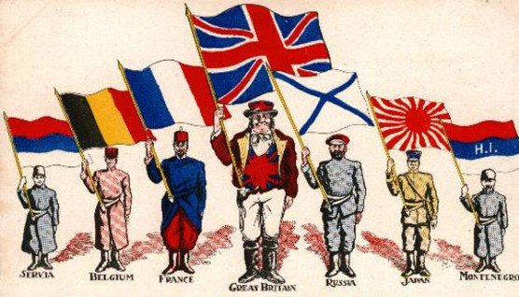
Imperialism | Imperialism is the practice of extending the rule or authority of an empire or nation over foreign countries, or of acquiring and holding colonies or dependencies (protectorates and spheres of influence). Imperialism is often motivated by nationalism, economic competition, and feelings of racial and cultural superiority. | 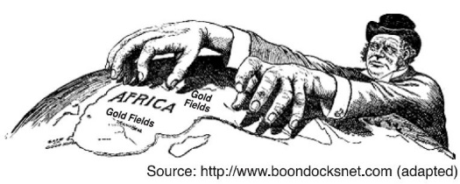
Fascism | A system of government most closely associated with Benito Mussolini of Italy that combines: totalitarian dictatorship, aggressive nationalism (including imperialism and xenophobia), glorification of politics, and single-party rule. | 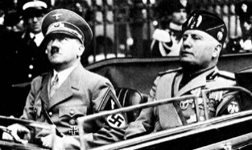
Mercantilism | Mercantilism was the dominant economic system of absolute monarchies from 1500 to 1800, whereby monopolies and regulations were put in place to extract wealth from colonies, thereby benefiting the mother country. | 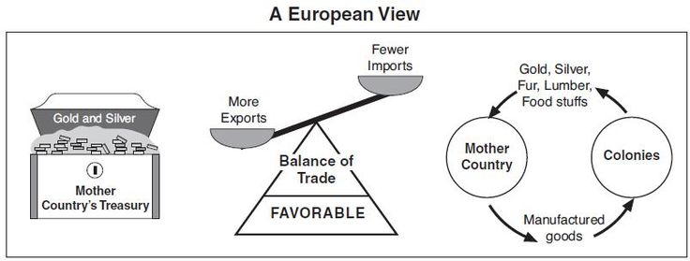
Capitalism | Capitalists believe in private ownership of resources and favor a system of competition in the free market to create economic growth and wealth, thus helping the nation’s overall prosperity. Since the Industrial Revolution, global capitalism has predominated. | 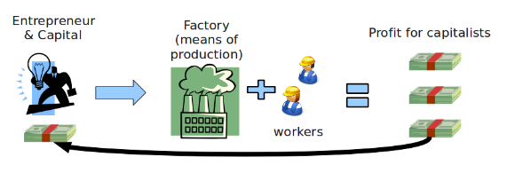
Socialism | Socialists are motivated by the desire to improve the quality of life for all members of society. They believe in strong state direction in political and economic policy, and redistribution of resources to address inequalities inherent in a free-market economy. | 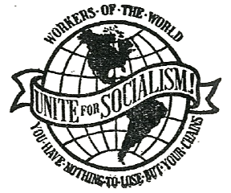
Communism | Communists believe that the capitalist system is damaging to the interests of the masses, and that workers must unite and overturn it by revolutionary means. Communists also believe in the state ownership of all land, natural resources and industry.

World Religions Chart
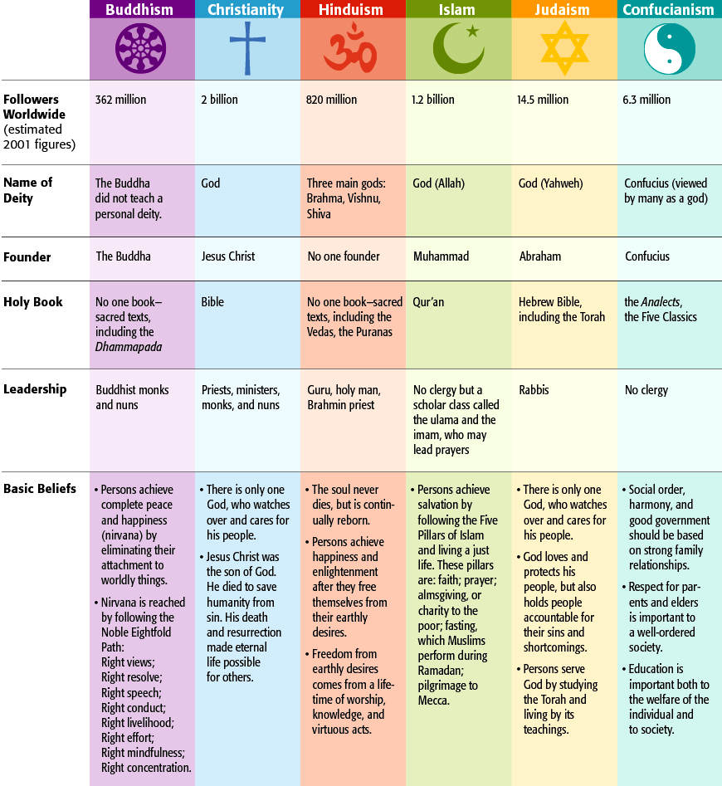

Suggested Primary Sources

Period 1 (Up to 600 B.C.E.)
- Rig Veda poems on Aryan culture
- Code of Hammurabi, first recorded code of laws
- Epic of Gilgamesh, Sumerian creation myth
- The Book of the Dead, ancient Egyptian funeral texts

Period 2 (600 B.C.E. to 600 C.E.)
- Lao Tzu, Daodejing Daoist teachings
- Confucius, Annalects Confucian sayings
- Herodotus, Histories on the Greco-Persian Wars
- Thucydides, History of the Peloponnesian War, about the war between Athens and Sparta
- Plato, Republic, about the ideal government
- Aristotle, Politics

Period 3 (600 to 1450)
- The Thousand and One Nights book of Arabian cultural stories
- The Epic of Sundiata West African epic poem
- Lady Murasaki, The Tale of Genji story about a Japanese court official
- The Chronicle of Jean de Venette account of a European on the bubonic plague
- Ibn Al-Wardi, "Risalha al-Naba", account of a Muslim on the bubonic plague

Period 4 (1450 to 1750)
- John Locke Two Treatises on Government, about natural human rights
- Montesquieu, The Spirit of the Laws, about structure of government
- Jean Jacques Rousseau, Discourse on the Foundations of Inequality, about society in politics
- Adam Smith, The Wealth of Nations, on capitalist theory
- Hobbes, Leviathan, on the problems of government and society
- Ibn Khaldun, "On the Rise and Decline of Empires", on the history of the Ottoman Empire

Period 5 (1750 to 1900)
- Rudyard Kipling, White Man's Burden, poem about European imperialism
- National Assembly, The Declaration of the Rights of Man and the Citizen, on French Revolution values
- Olympe De Gouges' The Declaration of the Rights of Women and the Female Citizen
- Thomas Paine, "Rights of Man" on individual freedom
- Mary Wollstonecraft, "Vindication of the Rights of Women", on gender inequality
- Elisa Greathed, "An Account of the Opening of the Indian Mutiny"
- John Stuart Mill, "On Liberty"
- Karl Marx, The Communist Manifesto, on communist theory
- Liang Qichao, A People Made New, on the westernization and modernization of China

Period 6 (1900 to the present)
- Aime Cesaire, Return to My Native Land poem about First World War
- Treaty of Versailles, outlining the plan for the end of the First World War
- Mohandas Gandhi, "Quit India" speech on Indian independence
- Winston Churchill, "The Iron Curtain Speech" on Cold War
- United Nations, International Declaration of Human Rights in response to 20th century genocides
- Henri Alleg, The Question, on the French use of torture during the French-Algerian War
- Lech Walesa, "Nobel Peace Prize Lecture" on the Solidarity Movement
Must Know Years

Period 1: Up to 600 B.C.E.
8000 B.C.E. - Neolithic Revolution
3000 B.C.E. – First state-based civilizations
1500 B.C.E. - Iron Age

Period 2: 600 B.C.E. to 600 C.E.
500s B.C.E. - life of Buddha, Confucius, Laozi
400s B.C.E. - Greek Golden Age
323 B.C.E. - Alexander the Great
221 B.C.E. - Qin unified China
32 C.E. - Beginnings of Christianity
180 C.E. - end of Pax Romana
220 C.E. - end of Han Dynasty
333 - Roman capital moved to Constantinople
476 - Fall of Rome
527 - Justinian rule of Byzantine Empire

Period 3: 600-1450
622 - Founding of Islam
732 - Battle of Tours
1054 - Great Schism (RCC & EOC)
1066 - Norman conquest of England
1071 - Battle of Manzikert (Seljuk Turks def. Byz)
1095 - 1st Crusade
1258 - Mongols sack Baghdad
1271-1295 - Marco Polo’s travels
1324 - Mansa Musa’s pilgrimage
1325-1349 - travels of Ibn Battuta
1347-1348 - Bubonic plague in Europe
1405-1433 - Zheng He’s voyages

Period 4: 1450 - 1750
1453 - Ottomans capture Constantinople
1488 - Dias rounded Cape of Good Hope
1492 - Columbus / Reconquista of Spain
1502 - 1st Slaves to Americas
1517 - Martin Luther / 95 theses
1521 - Cortez conquered the Aztecs
1533 - Pizarro toppled the Inca
1571 - Battle of Lepanto, (naval def. of Ottomans)
1588 - defeat of the Spanish Armada by the British
1600 - Battle of Sekigahara – Tokugawa unifies
1607 – Jamestown settled
1618-1648 - 30 years war
1683 - unsuccessful Ottoman siege of Vienna
1689 - Glorious Revolution / English Bill of Rights

Period 5: 1750 – 1900
Mid 1700s - Industrial Revolution begins in Britain
1756 - 1763 - 7 Years War / French and Indian War
1776 - American Revolution
1789 - French Revolution begins
1804 - Haitian independence
1815 - Congress of Vienna/ def. of Napoleon
1820s - Independence in Latin America
1839 - 1st Opium War in China
1848 - European revolutions / Comm. Manifesto
1853 - Commodore Perry opens Japan
1857 – Indian Rebellion (Sepoy Mutiny)
1861 - End of Russian serfdom / Italian unification
1863 - Emancipation Proclamation in US
1871 - German unification
1885 - Berlin Conference - division of Africa
1898 - Spanish-American War- U.S. gets territory
1899 - Boer War - British in control of South Africa
1905 - Russo-Japanese war
1910-1920 - Mexican Revolution
1911 - Chinese Revolution (Qing overthrown)

Period 6: 1900 to the present
1914 – WWI begins
1917 - Russian Revolution
1919 - Treaty of Versailles - end of WWI
1929 - Stock market crash
1931 - Japanese invasion of Manchuria
1935 - Italian invasion of Ethiopia
1939 - German blitzkrieg in Poland
1941 - Pearl Harbor, entry of US into WWII
1945 - End of WWII
1947 - Independence & partition of India
1948 - Birth of Israel
1949 - Chinese Communist Revolution
1950 - 1953 - Korean War
1956 – Nasser nationalizes Suez Canal
1959 - Cuban Revolution
1962 - Cuban missile crisis
1967 - 6-Day War / Chinese Cultural Revolution
1979 - Iranian Revolution
1989 - Tiananmen Square / fall of Berlin Wall
1991 - fall of USSR / 1st Gulf war
1994 – Rwanda genocide; Mandela in S. Africa
2001 - 9/11 Attacks
2003 – U.S. invasion of Iraq

