Novgorod, Russia - founded in the late 10th century. First mentioned in 862, when it was purportedly already a major Baltics to Byzantium station on the Trade route from the Varangians to the Greeks. The city's downfall was partially as a result of its inability to feed its large population, making it dependent on the Vladimir-Suzdal region for grain.
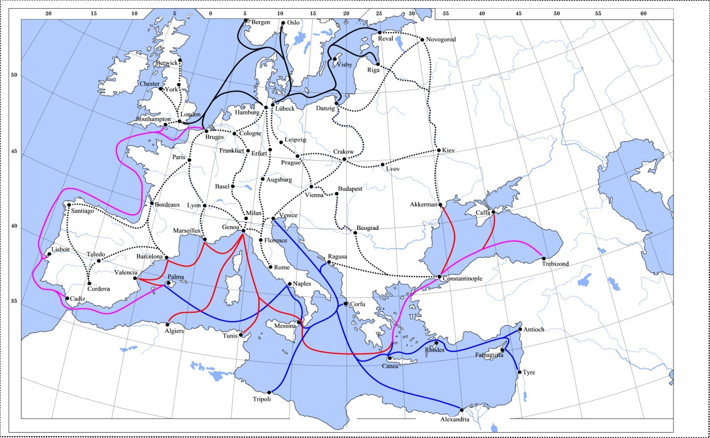
The black lines show the routes of the Hanseatic League, the blue Venetian and the red Genoese routes. Purple lines are routes used by both the Venetians and the Genoese. Overland and river routes are stippled.
Timbuktu, Mali - Starting out as a seasonal settlement, Timbuktu became a permanent settlement early in the 12th century. After a shift in trading routes, Timbuktu flourished from the trade in salt, gold, ivory and slaves. It became part of the Mali Empire early in the 14th century. In the first half of the 15th century the Tuareg tribes took control of the city for a short period until the expanding Songhai Empire absorbed the city in 1468. A Moroccan army defeated the Songhai in 1591, and made Timbuktu its capital. Located on the Niger River.
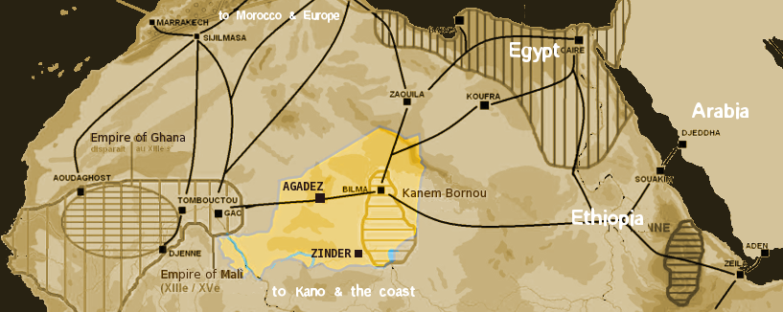
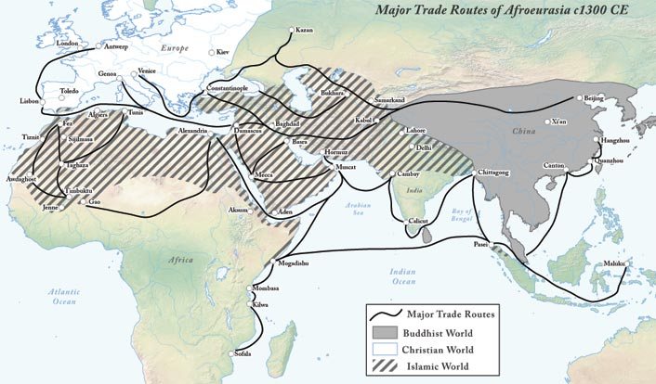

Calicut, India – On the western side of India called the Malabar Coast. Prospered from locally woven cotton textiles and locally grown grains and spices. They also served as clearing houses for the long-distance trade of the Indian Ocean. It was dubbed the "City of Spices" for its role as the major trading point of eastern spices. It was the capital of an independent kingdom ruled by the Samoothiris (Zamorins) in the Middle Ages and later of the Malabar District under British rule. Arab merchants traded with the region as early as 7th century, and Portuguese explorer Vasco da Gama landed at Kozhikode on 20 May 1498, thus opening a trade route between Europe and Malabar. A Portuguese factory and fort was intact in Kozhikode for short period (1511–1525, until the Fall of Calicut), the English landed in 1615 (constructed a trading post in 1665), followed by the French (1698) and the Dutch (1752). In 1765, Mysore captured Kozhikode as part of its occupation of Malabar Coast. Kozhikode, once a famous cotton-weaving center, gave its name to the Calico cloth. (Modern name Kozhikode)
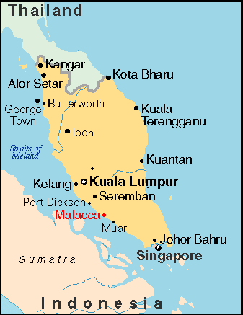
Melaka, Malaysia. Formerly spelled Malacca. In about the year 1400 the King of Tumasik (now known as Singapore), Paramesvara, fled an attack by the kingdom Majapahit. Taking refuge in a small fishing village on West Malaysia, he founded the kingdom of Melaka. For years, Malacca flourished under the watchful eyes of the Malay Sultans and the Chinese, until the struggle of power among the Europeans finally led to its slow and painful demise. Because of its strategic location, Malacca was an important stopping point for Zheng He's fleet. The local monarchy was abolished when the Portuguese conquered it in 1511. Then controlled by a variety of countires including the Dutch, British, Japan and then the Malayan Union becoming part of Malaysia in 1963.

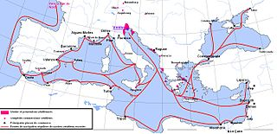
Venice, Italy. The town belonged to the Byzantine Empire until after the 4th Crusade and all trading ways opened up and a colonial empire developed. Venice was not a consumer center but rather developed techniques of trade, textile industry, forms of companies and methods of finance with control of the money market. During the 1200s, trade between Egypt, Syria, Southeast Asia, Iran and China was present, especially with their trade of spices, grain, wine, and salt. The spice trade with the east was the reason for Venice’s expansion of their high quality textile manufacturing. Thanks to Marco Polo’s opening of the silk route between Venice and the East in the thirteenth century, Venetian merchants established links between the Mongol Empire, Persia, Armenia, the Caucasus, and Asia Minor. The city was able to acquire many exotic goods used for garments, such as porcelain and pearl from the Far East; gems, mineral dyes, peacock feathers, and a profusion of textiles like silks, cottons, and brocades from Egypt and Asia Minor; minerals from Germany; wool and woven cloth from Flanders and England.
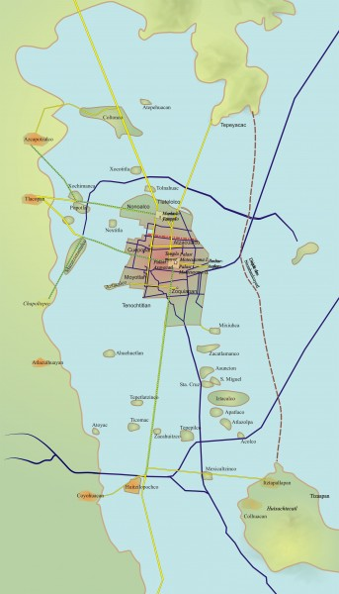

Tenochtitlan, Mexico. The Aztecs traded with many people in the area, but their main trade partners were the Mayans. The Aztec capital of Tenochtitlán (at modern Mexico City) was founded in 1345 on a muddy island in the lake that at that time filled the Basin of Mexico. The surrounding chinampa or ‘floating gardens’ (mud rafts secured with willow trees) of their immediate neighbors were, therefore, seized and developed to meet the needs of the growing population in the city. It remained the most important Aztec center until its destruction at the hands of the conquering Spanish led by Hernán Cortés in 1521 CE, which led to the final collapse of the Aztec Empire. Had huge market places with basic and luxury items such as jade, chocolate and vanilla

