DUE ON THE FIRST DAY OF SCHOOL!
WEBSITE: PFANNENSTIELHISTORY.WEEBLY.COM
CONTACT: ANDREW.PFANNENSTIEL@TUSD1.ORG @pfannenhistory

SUMMER ASSIGNMENT PART 1: Chronology
You are going to learn THE HISTORY OF THE WORLD(SERIOUSLY!!!) this year. Being able to put that history in a chronology will be essential to your ability to effective use and compare the massive amount of content we will be learning this year. Find dates(some will be a range, some will be a specific date) for the following events/topics bellow and place them in the region they are from. You can write your dates in two different ways seen below:
SPECIFIC DATES(EX: 524-355BCE) OR CENTURY(6th Century-4th Century BCE)
-Emergence of Homo Sapiens -Olmec Civilization -Chavin Civilization
-First fire use -Cuneiform created -Hieroglyphics created
-First use of tools -Assyrian Empire -Kingdom of the Hittites
-Out of Africa Theory -Indus River Civ -Vedic India
-Human migration to the America -Use of Iron -Kingdom of Nubia
-Egyptian Kingdoms(Old, Middle, & New) -Aryan Migration -Bantu Migration
-Sumer -Akkad Empire -Kingdom of Babylon
Africa | The Americas | Asia | Europe | Middle East
EXAMPLE: Emergence of Homo Sapiens 300,000 BCE

SUMMER ASSIGNMENT PART 2: MAPS
Use your textbook and online resources to complete the following THREE maps. Make sure that your complete each activity on the CORRECT MAP
Map#1:AP World Regions

Refer to page 35 in the AP World History Course Description(available on the AP website & my class website).Using the world map provided in this packet, draw and label the AP Regions based on the “closerview”(bottom map). You may color it if you would like but that is not a requirement. However, please use a color or striping to indicate any regions that overlap.

Map#2 :Major Empire/Civilizations for 8,000-600BCE
Using your textbook and online sources find the following Empires/Civilizations and place them on the map below. Use colors/pattern if there is any crossover or area shared by multiple Empires/Civilizations.

1. Shang Dynasty
2. Zhou Dynasty
3. Indus River Valley Civ
4. Egyptian River Valley Civ
5. Olmec
6. Chavin
7. Mesopotamia(General area)
8. Kingdom of Babylon
9. Assyrian Empire
10. Hittite Kingdom
11. Kingdom of Nubia

Map#3 :Important Geographic Features for 8,000-600BCE
Using your textbook and online sources find the following major geographic features and place them on the map below.
1. Atlantic Ocean 15. Aegean Sea
2. Pacific Ocean 16. Red Sea
3. Indian Ocean 17. Persian Gulf
4. Ganges River 18. Arabian Sea
5. Nile River 19. Gobi Desert
6. Tigris River 20. Sahara Desert
7. Euphrates River 21. Syrian Desert
8. Amazon River 22. Kalahari Desert
9. Indus River 23. Hindu Kush Mountains
10. Yellow River(HuangHe) 24. Himalayan Mountains
11. Yangtze River 25. Andes Mountains
12. Mediterranean Sea 26. Ural Mountains
13. Caspian Sea 27. Alps
14. Black Sea 28. Thar Desert

Map#1:AP World Regions
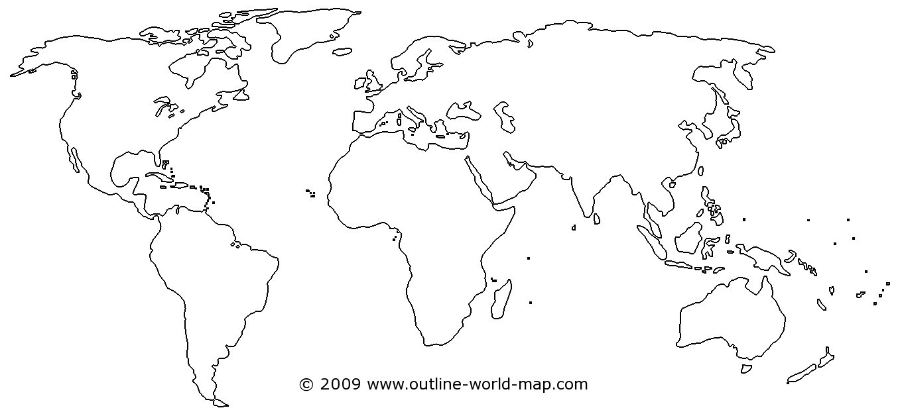

Map#2 :Major Empire/Civilizations for 8,000-600BCE
Map#3 :Important Geographic Features for 8,000-600BCE
SUMMER ASSIGNMENT PART 3: Crash Course Ep 1-3
For these questions you will watch episodes 1, 2, & 3 of Crash Course World History on Youtube. A link to this videos in also on my website under the SUMMER ASSIGNMENT SECTION. Answer these questions in concise bullet points(IN YOUR OWN WORDS

AGRICULTURAL REVOLUTION:
1. HOW DO WE HAVE EVIDENCE OF HUNTER-GATHERERS (H-G) AND THEIR LIFEWAYS?

2. WHAT ADVANTAGES DID HUNTER-GATHERERS HAVE OVER EARLY AGRICULTURALISTS?

3. WHERE DID AGRICULTURE EMERGE? WHICH FOOD CROPS ARE ASSOCIATED WITH WHICH AREAS?

4. WHAT ARE THE ADVANTAGES AND DISADVANTAGES OF AGRICULTURE?

5. WHAT IMPACT DOES AGRICULTURE HAVE ON THE ENVIRONMENT?

6. WHAT ADVANTAGES DO YOU THINK THAT EURASIA HAD WITH ITS ZOOLOGICAL SET OF ANIMALS COMPARED TO THE AMERICAS?

7. IF HUNTER-GATHERS HAD A “BETTER AND HEALTHIER” LIFEWAY, WHY DID PEOPLE BECOME AGRICULTURALISTS?

8. WHAT DO HISTORIANS SAY ARE THE DRAWBACKS TO COMPLEX CIVILIZATIONS AND AGRICULTURE?

INDUS VALLEY:
1. HOW IS THE CONCEPT OF “CIVILIZATION” A USEFUL CONSTRUCT? WHEN IS IT NOT A USEFUL CONSTRUCT?

2. HOW DOES JOHN GREEN DEFINE WHAT CONSTITUTES A CIVILIZATION? HOW DOES THIS COMPARE TO OTHER DEFINITIONS OF CIVILIZATION YOU HAVE LEARNED?

3. WHERE DID THE EARLIEST CIVILIZATIONS EMERGE? WHY THERE?

4. WHY WAS THE INDUS VALLEY A PRIME LOCATION? HOW DID THE ENVIRONMENT IMPACT THE PEOPLE WHO LIVED THERE?

5. WHAT EVIDENCE EXISTS OF LONGDISTANCE TRADE AND WITH WHOM?

6. WHAT APPEARS TO BE UNIQUE ABOUT THE IVC, BASED ON YOUR KNOWLEDGE OF OTHER CIVILIZATIONS?

ANCIENT MESOPOTAMIA:
1. JOHN GREEN BEGINS BY DISCUSSING ONE OF THE MOST OBVIOUS CONSEQUENCES OF AGRICULTURE...WHAT IS IT AND WHAT ARE THE MOST IMMEDIATE CONSEQUENCES FOR THOSE SOCIETIES?

2. HOW DOES MESOPOTAMIA COMPARE WITH THE INDUS RIVER VALLEY (IRV)? IDENTIFY BOTH SIMILARITIES AND DIFFERENCES. THINK OF WHY A SPECIFIC SIMILARITY AND A SPECIFIC DIFFERENCE MIGHT EXIST. (THIS IS ANALYSIS; ONE OF THE MORE CHALLENGING SKILLS YOU WILL NEED TO DEVELOP).

3. CUNIEFORM: WHAT THREE POINTS DOES JOHN GREEN MAKE ABOUT THE ADVENT OF WRITING?
a)

b)

c)

4. WHAT WAS HAMMURABI’S MOST SIGNIFICANT CONTRIBUTION?

5. WHAT ARE THE CHALLENGES OF EMPIRE WHAT IS THE USUAL RESULT? OR TO PUT IT IN MATH TERMS:
______________ + ________________ = ______________________

COMPLETE THE VENN DIAGRAM BELOW BASED ON THE INFORMATION GATHERED FROM THE CRASH COURSE VIDEOS
INDUS RIVER VALEY MESOPOTAMIA
SUMMER ASSIGNMENT PART 4: ISMS and Key Concepts Reference Resource
For each term you will need to:
- Create a concise HISTORICALY RELEVANT definition that is IN YOUR OWN WORDS
- Create a SPECIFIC HISTORICAL example (a kingdom/civilization where this was present, a historical event, an impact/effect of the event, ect)
- Placed in some sort of organized resource. ONE FOR ISM and ONE FOR KEY IDEAS/CONCEPTS
  - You can create this resource a few different ways depending on your preference. It could be in book format, notecard/flashcard, term chart, list format, quizlet, ect .(PICK THE FORMAT THAT WILL BE MOST HELPFUL YOU, NOT SIMPLY WHAT WILL BE THE LEAST AMOUNT WORK)
You will consistently come back to this as a resource and add to these lists as the year goes on so be sure this is easy to understand.
EXAMPLE OF A TERM:
Feudalism
Definition: The political, social & economic system. It is a loosely organized system of government in which local lords governed their own lands but owed military service and other support to a greater lord.
Historical Example: Japan during the Heian Period with peasants, samurai, and daimyo
ISMS! | KEY IDEAS/CONCEPTS!
Animism  Egalitarianism  Feudalism(GAVE YOU THAT ONE! You’re Welcome)  Feminism  Fundamentalism  Imperialism  Isolationism  Militarism  Monotheism  Pacifism  Pastoralism  Polytheism  Racism  Shamanism | Belief Systems  Bureaucracy  Chronology  Civilization  Colonization  Commerce  Craft-Specialization  Demographic  Empire  Fertile Crescent  Gender roles  Hierarchy  Hunter-Gathers  Ideology  Labor System(general term)  Neolithic Revolution  Nomad  Pandemic/Epidemic  Periodization  Reform (political reform, social reform, etc)  Revolution  Trade network

SUMMER ASSIGNMENT PART 5: Chapter One Reading Notes
Using the first chapter in your textbook you will be answering the following questions in concise bullet points(IN YOUR OWN WORDS) This will not only help introduce the development of human civilization and the adoption of agriculture, but will help prepare for taking effective reading notes , which you will be expected to do regularly throughout the school year.
You will use the first chapter in you textbook. World Civilization: The Global Experience which starts of page 8 in your book.
1.Describe significant differences between humans and other animals, especially other mammals

2. When was the Paleolithic Age? What are the significant dates of human migrations during the Paleolithic Age?

3. What significant developments did humans make during the Late Paleolithic Age? Of these developments, which do you feel are the most important? Explain your answer

4. When did humans begin agricultural practices? Describe the process of humans adopting agriculture and where agriculture first developed

5. Describe the advantages of peoples and communities adopting agriculture

6. What impacts did the adoption of agriculture have on humans and the development of society?

7. What groups did not adopt agriculture? Why?

8. Create a definition for civilization based on characteristics describe on pages 15-17.

9. List and describe at least 5 major characteristics of civilization based on the reading you have done

10. In 2-3 substantial paragraphs answer the following question. You response should include a thesis statement that is argumentative and specific(UNDERLINE YOUR THESIS). Your thesis will also need to be supported by at least THREE pieces of historical evidence form the first chapter of you book.
Why did human civilization develop AFTER the adoption of Agriculture and not during the time hunter gathers?

