Self-Guided Period 6
Directions: As you read Freemanpedia’s Period 6 page, complete the following questions using the information on the website, the links provided, and personal addition research if needed.
Key Concept 6.1 – Science and the Environment
- Innovations in transportation and communication
Innovation | When? | Significance?
Radio
Telephone
Cellular
Internet
Automobile
Airplane
WHAT PROBLEM DID THESE ADVANCMENTS IN TECHNOLGY AND COMMUNICATION ELIMINATE?
- Agricultural Production
There have been THREE major agricultural revolutions in world history. Identify how agriculture advanced in all the following periods:
- Period 1 –Neolithic Revolution (use your notes)
- Period 5 – Industrial Revolution (use your notes)
- Period 6 – The Green Revolution

- Define: Green Revolution

- Define: Commercial Agriculture

- Define: GMCs (aka GMOs)

WATCH: “The Green Revolution: Waging a War Again” and “Bill Nye – GMO Foods”

- The Green Revolution and commercial agriculture increased ____________________ and sustained the earth's growing ___________________ as it spread ____________________ and _____________________ modified forms of agriculture.
- Medical Innovations
Disease has been a persistent enemy since period 1, but many deadly diseases were eradicated or reduced significantly through vaccinations. Identify 10 of these diseases and the date of the vaccination. Do a quick Google search of the disease if you don’t know what it is
DISEASE | DATE of VACCINE | DISEASE | DATE of VACCINE
1. |  | 6.
2. |  | 7.
3. |  | 8.
4. |  | 9.
5. |  | 10.

- Demographic Shifts

- Disease, scientific innovations, and conflict led to demographic shifts.
Identify and briefly describe 3 epidemics of the 20th century.
Identify and briefly describe 3 diseases associated with lifestyle.
Identify and briefly describe 3 diseases associated with poverty.

Key Concept 6.2 – Global Conflicts and their Consequences
ARMED STRUGGLE FOR INDEPENDENCE
 | Kenya | Algeria | Angola | Vietnam | Mau Mau
Date of independence?
Gained independence from?
Separatist movements challenged imperial/colonial boundaries and borders. Three must know examples are:
- Define: Quebecois

- Define: Biafra
- Define: Muslim League

- The migration of former colonial subjects to imperial metropoles (the former colonizing country, usually in the major cities) maintained cultural and economic ties between the colony and the metropole even after the dissolution of empires.
- On the map, show the migration patterns of South Asians, Filipinos, and Algerians.
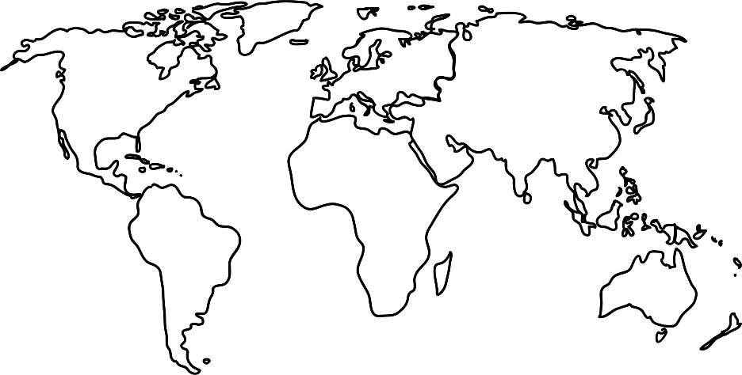
- Although conflict dominated much of the twentieth century, many individuals and groups — including states — opposed this trend. Some individuals and groups, however, intensified the conflicts. Complete the first chart with the names of three nonviolent leaders and basic actions taken by each and the second chart on challenges to the established order.
Challenge | How did they challenge the social/economic/political order?
Non-aligned movement
Anti-apartheid
1968 Global protests
Tiananmen Square

- Some groups used terrorism to achieve their goals.
Group | Goal
Irish Republican Army
Al Qaeda

Key Concept 6.3 – New Conceptions of Global Economies, Societies, and Cultures
- Movements sought to envision society in new ways.
 |  | How did this challenge previously held assumptions?
Race | Negritude
Class | UN Universal Declaration of Human Rights
Gender | Feminism
Religion | Liberation Theology

- Political and social changes of the 20th century led to changes in the arts and literature. In the second half of the century, popular and consumer culture became more global.
Complete the chart with 4 examples and major characteristics

