Communism and Socialism Introduction
Communism and socialism are umbrella terms referring to two left-wing schools of economic thought; both oppose capitalism. These ideologies have inspired various social and political movements since the 19th century. Several countries have been or are currently governed by parties calling themselves communist or socialist, though these parties' policies and rhetoric vary widely.
As an ideology, communism is generally regarded as hard-left, making fewer concessions to market capitalism and electoral democracy than do most forms of socialism. As a system of government, communism tends to center on a one-party state that bans most forms of political dissent. These two usages of the term "communism" – one referring to theory, the other to politics as they are practiced – need not overlap: China's ruling Communist Party has an explicitly pro-market capitalist orientation and pays only lip service to the Maoist ideology whose purist adherents (Peru's Shining Path in its heyday, for example) regard Chinese authorities as bourgeois counterrevolutionaries.
Socialism can refer to a vast swath of the political spectrum, in theory and in practice. Its intellectual history is more varied than that of communism: the Communist Manifesto devotes a chapter to criticizing the half-dozen forms of socialism already in existence at the time, and proponents have taken just about every left-of-center stance on the ideal (or best achievable) structure of economic and political systems.
Socialists can be pro- or anti-market. They may consider the ultimate goal to be revolution and the abolition of social classes, or they may seek more pragmatic outcomes: universal healthcare, for example, or a universal pension scheme. Social Security is a socialist policy that has been adopted in the unabashedly capitalist U.S. (as are the eight-hour working day, free public education and arguably universal suffrage). Socialists may run for election, forming coalitions with non-socialist parties, as they do in Europe, or they may govern as authoritarians, as the Chavista regime does in Venezuela.

Defining Communism and Socialism
To better understand the slippery distinctions between communism and socialism, let's trace the history of both terms.
Communism
Communism traces its roots to "The Communist Manifesto," an 1848 pamphlet by Karl Marx and Friedrich Engels. The document laid out a theory of history as a struggle between economic classes, which will inevitably come to a head through a violent overthrow of capitalist society, just as feudal society was violently overthrown during the French Revolution, paving the way for bourgeois hegemony (the bourgeoisie is the class that controls the means of economic production).
Following the communist revolution, Marx argued, workers (the proletariat) would take control of the means of production. After a period of transition, the government would fade away, as workers build a classless society and an economy based on common ownership. Production and consumption would reach an equilibrium: "from each according to his ability, to each according to his need." Religion and the family, institutions of social control that were used to subjugate the working class, would go the way of the government and private ownership.
Marx's revolutionary ideology inspired 20th-century movements that fought for, and in some cases won, control of governments. The Bolshevik revolution in 1917 overthrew the Russian czar and following a civil war established the Soviet Union, a nominally communist empire that collapsed in 1991. The Soviet Union was only "nominally" communist because, while ruled by the Communist Party, it did not achieve a classless, stateless society in which the population collectively owned the means of production.
In fact, for the first four decades of the Soviet Union's existence, the Party explicitly acknowledged that it had not created a communist society. Until 1961, the Party's official stance was that the Soviet Union was governed by the "dictatorship of the proletariat," an intermediate stage along the inevitable progression towards the final stage of human evolution: true communism. In 1961, Premier Nikita Krushchev declared that the Soviet state had begun "withering away," though it would persist for another three decades. When it did collapse in 1991, it was supplanted by a nominally democratic, capitalist system.
No 20th- or 21st-century communist state has created the post-scarcity economy Marx promised in the 19th century. More often, the result has been acute scarcity: tens of millions of people died as a result of famine and political violence after the People's Republic of China was established in 1949, for example. Rather than eliminating class, China's and Russia's communist revolutions created small, enormously wealthy Party cliques that profited from connections to state-owned enterprises. Cuba, Laos, North Korea and Vietnam, the world's only remaining communist states (with the exception of de facto capitalist China), have a combined gross domestic product (GDP) roughly the size of Tennessee's.
Socialism
Socialism predates the Communist Manifesto by a few decades. Early versions of socialist thought were articulated by Henri de Saint-Simon (1760-1825), who was himself an admirer of ur-capitalist Adam Smith, but whose followers developed utopian socialism; Robert Owen (1771-1858); Charles Fourier (1772-1837); Pierre Leroux (1797-1871); and Pierre-Joseph Proudhon (1809-1865), who is famous for declaring that "property is theft."
These thinkers put forward ideas such as a more egalitarian distribution of wealth, a sense of solidarity among the working class, better working conditions, and common ownership of productive resources such as land and manufacturing equipment. Some called for the state to take a central role in production and distribution. They were contemporary with early workers' movements such as the Chartists, who pushed for universal male suffrage in Britain in the 1840s and 1850s. A number of experimental communities were founded based on the early socialists' utopian ideals; most were short-lived.
Marxism emerged in this milieu. Engels called it "scientific socialism" to distinguish it from the "feudal," "petty-bourgeois," "German," "conservative" and "critical-utopian" strains the Communist Manifesto singled out for criticism. Socialism was a diffuse bundle of competing ideologies in its early days, and it stayed that way. Part of the reason is that the first chancellor of newly unified Germany, Otto von Bismarck, stole the socialists' thunder when he implemented a number of their policies. Bismarck was no friend to socialist ideologues, whom he called "enemies of the Reich," but he created the West's first welfare state and implemented universal male suffrage in order to head off the left's ideological challenge.
Since the 19thcentury, a hard-left brand of socialism has advocated radical societal overhaul – if not an outright proletarian revolution – that would redistribute power and wealth along more equitable lines. Strains of anarchism have also been present in this more radical wing of the socialist intellectual tradition. Perhaps as a result of Bismarck's grand bargain, however, many socialists have seen gradual political change as the means to improving society. Such "reformists," as hardliners call them, were often aligned with "social gospel" Christian movements in the early 20thcentury. They logged a number of policy victories: regulations mandating workplace safety, minimum wages, pension schemes, social insurance, universal healthcare and a range of other public services, which are generally funded by relatively high taxes.
After the world wars, socialist parties became a dominant political force in much of Western Europe. Along with communism, various forms of socialism were heavily influential in the newly decolonized countries of Africa, Asia and the Middle East, where leaders and intellectuals recast socialist ideas in a local mold – or vice-versa. Islamic socialism, for example, centers on zakat, the requirement that pious Muslims give away a portion of their accumulated wealth. Meanwhile socialists across the rich world aligned themselves with a range of liberation movements. In the U.S., many, though by no means all, feminist and civil rights leaders have espoused aspects of socialism.
On the other hand, socialism has acted as an incubator for movements that are generally labeled far-right. European fascists in the 1920s and 1930s adopted socialist ideas, though they phrased them in nationalist terms: economic redistribution to the workers specifically meant Italian or German workers and then only a certain, narrow type of Italian or German. In today's political contests, echoes of socialism – or economic populism, to critics – are easily discernible on the both the right and left.
CLASSICAL LIBERALISM
Closely tied to capitalism is the philosophy of Classical Liberalism. In the same way that capitalists believe the economy should not be regulated by the government, Liberalism holds that individual choice should not be limited by those in power. This idea of liberty, most associated with the English philosopher John Stuart Mill, maintains that an individual should be able to do anything they freely chose as long as it does not harm another person. Consequently, Classical Liberals believe in freedom of speech, the press, and individual belief. They echo the voices of the earlier Enlightenment in that a government should have the consent of its people.
Liberalism, or what we might now refer to as "classical liberalism" to distinguish it from today's usage of the term, emerged as a reaction to Europe's decaying feudal order in the 17th and 18th centuries. The rising urban business class, sometimes called the bourgeoisie, sought increased political influence to match their growing economic and social power. Momentum for change accelerated as political philosophers, developing ideas of natural rights and the social contract, began to articulate an ideology that rejected hereditary privilege and fit the political aspirations of these growing political actors. These ideas were profoundly influenced by two major movements in Western civilization. The first movement was the Protestant Reformation and its notion that a person has an individual relationship with the divine. The second movement was the Enlightenment with the assumption that the world has a natural order that individual reason can discover and understand independently of faith, a rationalist philosophy.

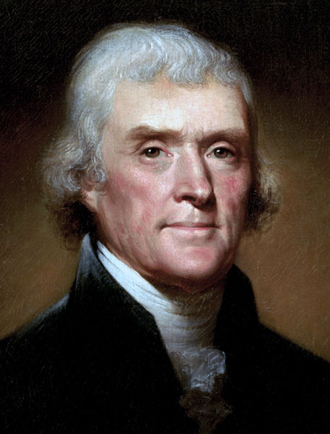
Individualism
Classical liberalism holds that there are certain natural rights of which no government, elected or otherwise, may deprive its citizens. This is an important distinction. Governments do not give rights to their citizens. Rights belong to citizens because they are inherent in the natural order or granted by God Almighty (take your pick). John Locke, a political theorist of the 18th century identified three such basic rights, "life, liberty, and property." Thomas Jefferson memorably plagiarized Locke's idea in the Declaration of Independence when he wrote that all men share certain inalienable rights, among them "life, liberty, and the pursuit of happiness."
Given the political and economic interests of its beneficiaries, classical liberalism places a very strong emphasis on the individual's right to property. This ideology is thus a natural favorite for proponents of a capitalist economic system. A capitalist economy allocates economic decision-making to individuals meeting in free markets. In such a system individuals, rather than the state, are the predominant owners of property. This highlights another key aspect of classical liberalism: its clear suspicion of centralized political power and its earnest advocacy of limited government. You may recall another famous phrase credited to that prolific phrase-turner, Thomas Jefferson: "That government is best which governs least."
Limited Government
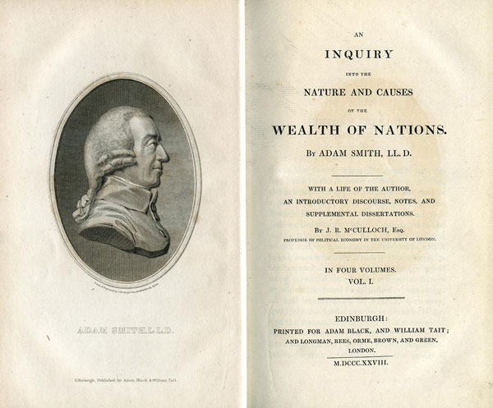
This emphasis on limited government is notable in three particulars. First, classical liberalism is hostile to government interference in the marketplace. It was a reaction against the repressive medieval guild system of trades and the heavy-handed state policy of mercantilism, typified under France's economic minister, Colbert. Adam Smith, a Scottish political economist, invoked the metaphor of an invisible hand to describe how individual selfishness in an unregulated economy actually promotes the public good. More bluntly, big government is bad for business and prosperity. Second, the classical liberal tradition emphasizes separation of church and state (though not always the wall of separation endorsed by some modern constitutional scholars). The emerging business elites who embraced classical liberalism were often Protestants and victims of persecution or discrimination by Catholic, Anglican or other state churches. State control of religious practice was bad for business and, more fundamentally, a matter best left to individual conscience. They saw proof for these points in the apocalyptic bloodshed of Europe's Thirty Years War, a war waged in the name of religion.
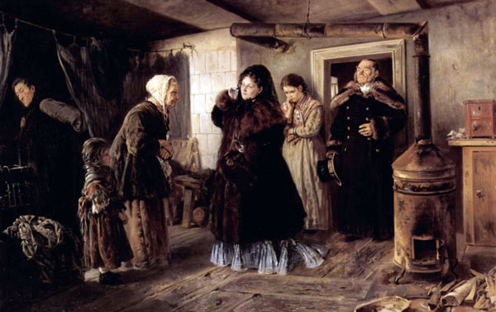
Third, while the classical liberal tradition celebrates civil society (associations of individuals and institutions outside of government control) and charitable giving to the poor, it rejects the proposition that the state is responsible for the welfare of society's less fortunate, whether the poor or ill. This is a notable difference between classical liberalism and socialism. It is inclined to see an individual's fate as the outcome of his or her individual decisions, good or bad. It is relatively optimistic about an individual's capacity for self-transformation and accents individual responsibility. It is skeptical of theories emphasizing environmental determinism (the idea that individuals are severely limited by the social conditions into which they are born). The cliché maxim that someone should "pull himself up by his own bootstraps" is a reflection of the liberal ideal. Thus concerning the cardinal value of equality, it embraces equality of opportunity but rejects equality of results. Classical liberalism is adverse to the welfare state.
In conclusion, classical liberalism is a political ideology grounded in the notion of individualism and limited government, with a large helping of property rights on the side. It demands formal political and legal equality, but does not require or even expect social and economic equality.

