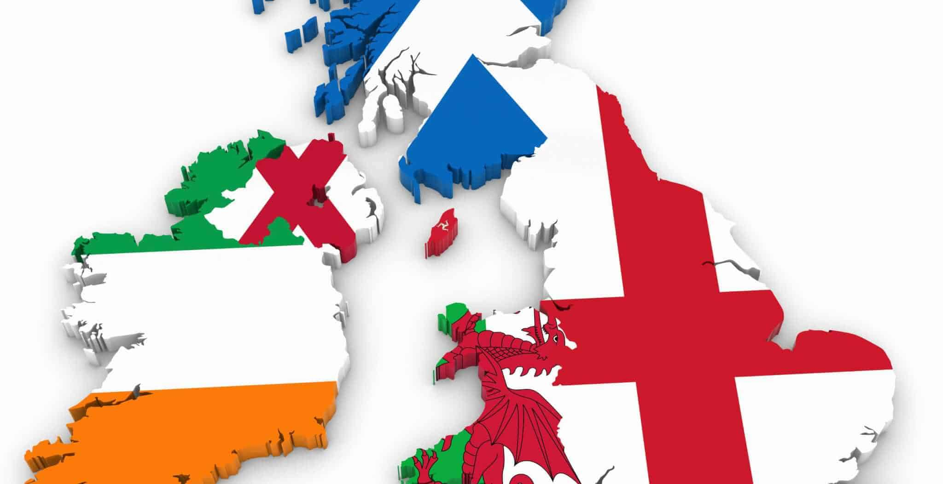
FORCED TO BE A UNITED KINGDOM OF BEANS ON TOAST
INGREDIENTS | DIRECTIONS
- TWO PIECES OF RELIGIOUSLY DIVERSE BREAD, ONE CATHOLIC & ONE PROTESTANT  - ONE CAN OF ENGLISH COLONIZING THE BRITISH ISLES BEANS  - KETCHUP THAT IS NEEDS TO BE OFFICIALLY APPROVED BY THE LONDON PARLIAMENT  - CHEDDAR CHEESE MADE BY IRISH TERRORISTS IN NORTHERN IRELAND  - OPTIONAL BREAKFAST TEA SEASONED WITH FAIELD SCOTTISH INDEPENDENCE REFERENDUM | 1ST TOAST YOUR BREAD OVER A LOW FLAME OF RELIGIOUS DISAGREEMENT, TENSION, & WARFARE BETWEEN PROTESTANT AND CATHOLICS  2ND SLOW COOK YOUR BEANS WITH HUNDREDS OF YEARS OF WAR BETWEEN THE WELSH, ENGLISH, SCOTTISH, & IRISH(THE ENGLISH FLAVOR WILL BE STRONGEST)  3RD ONCE YOUR BREAD IS FULLY TOASTED POUR YOUR ENGLISH DOMINATED BEANS ON TOP  4TH SPRINKLE DECADES OF TERRORIST ACTIONS IN NORTHERN IRELAND CHEESE ON TOP OF THE BEANS  5TH ADD PARLIAMENT APPROVED KETCHUP ON THE SIDE  6TH ENJOY WITH A NICE OF CUP OF TEA THAT WILL ONLY ANGER THE SCOTS MORE
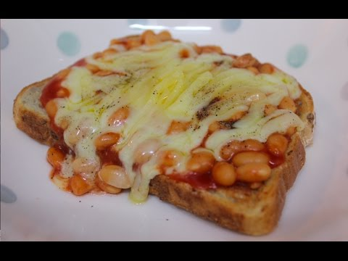
FINISHED PRODUCT
- YOUR INGREDIENTS MAY NOT SEEM LIKE THEY REALLY GO TOGETHER, BUT THEY WILL WORK TOGETHER BETTER THAN YOU THINK
- WHEN FINISHED YOUR BEANS ON TOAST SHOULD BE LOOSELY HELD TOGETHER
- EACH INGREDIENT IN THE BEANS WILL RETAIN A BIT OF UNIQUE FLAVOR AND HAVE ITS OWN PARLIAMENT
- HOWEVER THE ENGLISH BEANS MAY KIND OF OVERSHADOWED EVERYTHING ELSE
- PEOPLE OUTSIDE OF THE UNITED KINGDOM WILL NOT REALLY BE ABLE TO UNDERSTAND HOW YOUR DISH WORKS
- YOU WILL LIKELY MEET & READ MANY DIFFERENT METHODS & DISAGREEMENTS OVER HOW TO ASSEMBLE BEANS ON TOAST ONLINE

