Agriculture and Pastoralism transformed human societies
A. The ability to acquire food on a regular basis drastically changed life; there was more stability and order. Life developed according to special patterns, as people had to follow seasons for planting and harvest. The dependence upon nature was evident in religious practices that came to worship reproduction, fertility, and the natural elements upon which agriculture depended. Probably the most significant change that took place with the Neolithic revolution was a dramatic increase in population. More food could sustain more people living together. Small bands of people developed into villages.
B. At its most basic element, civilization is based on the food supply. In hunting/gathering societies, most all of the people were engaged in acquiring and processing food. For this reason, as we have seen, there was a higher degree of equality. There were no significant differences that distinguished certain people from others. However, in communities that practiced agriculture this basic equality began to break down. The surpluses of food produced by farming created the conditions for the rise of social inequality.
The ability to produce a surplus freed some people from having to spend all their time producing food; individuals could now specialize in other skills. Artisans crafted weapons, jewelry, and other specialty products that could not be produced as readily by nomadic people. Moreover, surpluses of food created the need for a warrior class to emerge. The stores of grain kept by neolithic people were the perfect targets for raiding groups of nomadic people. Some members of the village thus were trained in the skills of defense to protect the fruit of their labor; the first militaries were born. With these divisions of people came inequality. Some groups gained more prestige and status than others. Priests who presided over rituals that were believed necessary for harvests gained elite positions and authority. Warriors were essential for the protection of food. Highly skilled craftsman who could work with metals or produce tools became highly valued. Thus social hierarchies emerged in societies that were able to produce surpluses of food.
C. As societies became more established and generated more wealth inequalities became wider. Merchants, the priestly class, or military elites gained high honor and status than ordinary people. The organization of people into hierarchical groups from highest to lowest is called stratification. Another way in which inequality expanded was across genders. Sometime after the Neolithic Revolution patriarchy emerged. Patriarchy refers to a social system in which males have more respect, authority, or control than females.
D. As groups of craftsmen and artisans arose in societies, tools and technology became more efficient and complex. Agricultural production increased, societies began to trade, and transportation improved. Some examples of these advancements are:
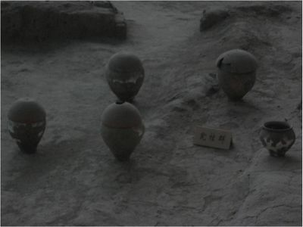
- Pottery Agriculture created the need for storage containers and cooking pots. In response to this need, craftsmen learned to make pots from clay and other materials, and they became essential for storing food, wine, and other goods. They could also be used for religious or ceremonial purposes. Pottery became a medium for group identity and artistic expression as people came to etch designs on the exterior of pots.

These pots excavated at the Banpo village in China show the craftsmanship of neolithic people in creating pots. Over 400 of these pots were unearthed at Banpo. Many had the remains of infants inside. The holes on top are thought by some to indicate the peoples' belief in the afterlife, as the souls of the dead children inside could escape through the top.

- Plows Tools permit the same amount of work to be done by fewer people. In agriculture, perhaps the most important early tool was the plow. Plows break up the compacted earth and turn the soil to prepare for the sowing of seeds. The more efficient the plow, the fewer number of workers are needed to prepare for planting. More efficiency in agriculture led to greater surpluses, which in turn allowed for more social stratification and specialization.
- Woven textiles In 1991 two hikers in the Italian Alps discovered a neolithic man whose body had been preserved in a glacier for over 5000 years. "Iceman," as he came to be called, provided modern researchers with much information about the diet, clothing, and skills of European neolithic people. This was particularly important because textiles decay quickly in most instances leaving us with little evidence about this skill of early man. Two of iceman's possessions were items that had been woven. This craft is known as textiles. Early textiles were made of dried plants and fibers, and were woven by hand. Later, people made looms to speed up the process of textile production. In villages and cities, textile production became another skilled craft, another example of the specialization of labor.
Early textiles from East Asia
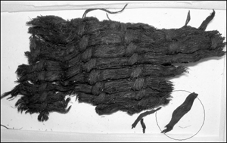
- Metallurgy Another area of craftsmanship that neolithic people developed was metallurgy, the knowledge of working with metal. This technology is very important because it provides the tools for many other areas of labor, such as farming, textiles, and the forging of weapons.
The earliest metallurgists worked with copper, a metal that can be hammered into shape directly from the ground. As new metals were found and alloys discovered, metallurgy became a highly skilled practice. Metals have different densities, grains, and characteristics that must be learned. A major break-though in metallurgy was Bronze. Bronze is an alloy of copper and tin. It required these base metals to be heated and mixed together, but the result is a product that is harder and more useful than the softer copper, which cannot hold a cutting edge for long. Bronze would transform human societies by producing larger surpluses of agriculture and allowing for the creation of superior weapons.
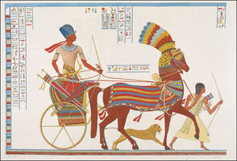
- Wheels and wheeled vehicles The wheel was invented in the late neolithic period in Mesopotamia and in the northern Caucasus region of Central Europe. In its most obvious application, the wheel can be used in vehicles to facilitate the movement of goods. Moreover, the Hittites developed the chariot, a wheeled vehicle used in battle. When the Hyksos gained chariots they were able to successfully invade Egypt. Wheels also contributed to the advancement of other crafts. Pottery could be turned on a horizontal wheel, and they could be used for spinning yard. Later, the power of moving water could be harnessed with a water wheel. Numerous toys have been found with wheels.

